KABUMBU FOOTBALL LEAGUE INFORMATION SYSTEM

**Kenya Certificate of Secondary Education**

**C:\Program Files\Microsoft Office\MEDIA\CAGCAT10\j0299763.wmf**

Name: Kokonya George Blasio

Index number: 20404049022

Presentation year: Year 2014

School : St. Hannah’s Boy’s High School

Examination body: Kenya National Examination Council

DECLARATION

I certify that this is a true report of my computer project that I carried out without any assistance other than explanation by the teacher as the supervisor of the project.

ACKNOWLEDGEMENT

I want to appreciate and thank God, Mr. Juma, my parents and the St.Hannahs institution who have supported me and helped in the making of the project. Most of all I want to thank Mr. Juma for getting me far in computer studies.

4. ABSTRACT

The project is meant to design a computerized system whereby Kabumbu Football League organization can manage its data. The system is meant to capture the appropriate data and perform the required calculations.

The system is meant to gather information from various methods such as observations and questionnaires’. Observation involves watching people as they carry out their activities.

The system faced some ideal challenges whish hindered the project developments. One of the problems was presence of viruses which affected the system.

|  |
| --- |
| TABLE OF CONTENTS  Chapter 1   1. Introduction 2. Information gathering 3. Analysis of the existing system 4. Problem definition 5. Solution 6. Limitations of the existing system 7. Scope of the system 8. Objectives of the system 9. Benefits of the system 10. Feasibility study |

LIST OF TABLES

ABBREVIATION

KFL-Kabumbu Football league

KSH-Kenya shillings

# CHAPTER 1: Introduction

## 1.0 Background image of the study organization

Kabumbu football league management is a secondary school organization charged with managing all inter-school football completions in a county. There are a total of 14 schools which have enrolled their teams and new schools are registered in order to present their teams. Registration fee for a team is KSH 50000 per year. Each school can only register one team.

A team comprises of 18 students who are players and coach who is a teacher in the school where the team belongs. At the beginning of every school game season, each school is required to furnish Kabumbu football management with the team’s details.

All football matches between schools in the county are scheduled for term one of every year in which each pair of teams plays 2 matches. References who will be officiating matches are teachers who are prohibited from officiating matches involving their schools. At the end of the season teams are awarded.

## 1.2 Information Gathering

The data was collected using the following methods:

1. Observation
2. 2. Interviews

### 1.2.1 Observation

Observation involves watching how people carry out their activities. The analyst went to Kabumbu Football League organization and saw the director for Kabumbu Football League Organization. The director showed the analyst a sample of a fixture. The fixture contains details of the teams that are to play, the time and place where the match will be played and the coach officiating the match.

The analyst also went to Nairobi Academy and spoke to the football coach. The coach showed the analyst how the students train each day to prepare for the league. The students train each evening From 5 pm to 6pm.

### 1.2.2 Interviews

The analyst went to Kabumbu Football League organization and saw the Manager for football matches. The analyst interviewed the manager with the main aim of knowing how the organization record details .The organization record details manual on paper then enters data later on the computer for storage purposes.

The analyst visited Nairobi Academy and saw the football coach. The analyst‘s objective was to know the qualifications of a student to enter the school team. Qualification to play in a team. For a student to be chosen to play in a team, the student must have speed, stamina and good ball control.

## 1.3 Analysis of the existing system

Kabumbu Football League is a secondary school organization charges with managing, all inter-school completions in a county. There are a total of 14 schools which have enrolled their teams and new schools are required to register in order to present their teams. Registration for a team is Ksh.50000 per year. The team registering can pay through M-pesa or pay in cash. Each school can only register only one team.

A team presented comprises of 18 students and a coach who is teacher in the school where the team belong. At the beginning of every footballs game season, each school is required to furnish Kabumbu Football League management with the team’s details.

All football matches between schools in the county are scheduled for term one of every one year. The game is played in a league basis, where each team is paired with another team. Each pair players to matches; home and away. The season’s fixtures are determined before the beginning of the season.

In a match, the goal scored by each team and the goals scored are recorded. A win in a game earns team 3 points, a draw 1 and a loss 0. A player who violets a football rule earns a penalty card. A player who 1 or 2 yellow cards is cautioned but, if a player gets 3 yellow cards or a red card, the player is removed from the match and banned from playing the next two matches.

A team whose opponent fails to honor a fixture is awarded 2 points while the opponent does not earn any point. After every game, a league table is updated based on the results of the match .The team with the highest points is the winner.

At the end of the season 30% of the amount collected as registration fee is awarded to the best 3 teams in the ratio 3:2:1 respectively. The best team carries the county’s trophy for the season.

The team that earns the lowest number of penalty cards by end of the season is considered most disciplined. The 3 most disciplined teams are each awarded a certificate. A team that fails to honour a fixture is not eligible for this award. The 3 least disciplined team are reprimanded.

## 1.4 Problem definition

The problem of the current system is that it carries out activities manually. The current manual system consumes a lot of time capturing data and it is difficult to operate the manual system.

## 1.5 Solution

The solution to the current problem is to develop a well-documented computerized system that will be charged with registration and managing inter-school completions.

## 1.6 Limitations

1. Frequent loss of data
2. Hard to maintain the system for example allowing stored data to be updated.
3. Expensive to maintain and operate the current system.

## 1.7 Scope of the system

The system should;

1. Register schools, referees, coaches and players in each team.
2. Keep a record of payments of each school.
3. Keeps a schedule of fixtures for matches involving schools including officiating referees.
4. captures a list of match results for every team over the season
5. Generate a league table in order of merit.
6. Display a list of the; Players in each team, coaches, schools and the amount of money collected from each school, top ten scorers in descending order of scores, teams qualifying for the awards and the amount that each gets, Teams qualifying for certificates and the teams reprimanded.

## 1.7.1 Objectives of the system

1. To register schools, players in each team, referees and coaches.
2. To catch appropriate data for example to capture a team’s details.
3. To carry out the required calculations for examples to calculate the total amount of money received from the registration of schools.

## 1.7.2 Benefits of the system

1. The system prevents loss of frequent loss of data.
2. The system will be easy to maintain.
3. The systems will be easy to operate.

# CHAPTER 2: Feasibility Study

## 2.1 Schedule feasibility

The development of the system will take 5 months. The developer will require full co-operation from everyone to develop the system within the allocated time. The developer will also require a lot of patience and concentration in developing the system.

## 2.2 Technical feasibility

The technology required to develop the new system is readily available in the market. The developer will choose the required items used to develop the system. The developer will also need some technical help in –order to develop a well computerized system.

## 2.3 Operational feasibility

The system developer is happy with the development of the proposed system. The system developer has received full support and co-operation from everyone and therefore the system developer is comfortable with the proposed system.

Cost benefits analysis

Cost: The entire development and operational costs can be estimated as follows;

Development=Ksh.50000

Monthly operational costs=Ksh.50000

Total lifetime of the new system =KSH 500000+(12months*Ksh500000)=KSH 2300000

Benefits:

1. Reduced the cost of repairing the old system since it suffered from frequent breakdown.=KSH 20000

Total monthly benefits=KSH 10000 Total lifetime costs benefits=(10000*12months*3years)

=KSH 480000

Conclusion

The development of the new system is cost effective and beneficial to the organization because the lifetime benefits greatly outweigh the cost.



Table 2.1 registration

|  |  |  |  |
| --- | --- | --- | --- |
| Field name | Data type | Field size | Description |
| School name | Text | 20 | Identifies the name of the school |
| Team name | Text | 20 | Identifies the name of the team |
| Registration number | Number | 10 | Identifies the registration number of the school |
| Address | Memo | 11 | Identifies the address of the school |
| Location | Text | 10 | Identifies the location of the school |
| Registration fee | Number | 7 | Identifies the registration fee the school pays |

Table 2.4 Players

|  |  |  |  |
| --- | --- | --- | --- |
| Field name | Data type | Field size | Description |
| Player name | Text | 20 | Identifies the name of the player |
| Team name | Text | 20 | Identifies the name of the team |
| Age | Number | 3 | Identifies the age of the player |
| Player number | Number | 3 | Identifies the number of the player |
| Contacts | Number | 15 | Identifies the contacts of the player |

Table .

Table 2.6Award

|  |  |  |  |
| --- | --- | --- | --- |
| Field name | Data type | Field | Description |
| Team category | Text | 15 | Identifies the team category |
| Team name | Text | 20 | Idenifies the name of the team |
| Position | Number | 3 | Identifies the position of the team |
| Award | Text | 10 | Identifies award obtained by the team |
| Amount | Number | 10 | Identifies the amount the team gets |

Table .

Table 2.7Coach

|  |  |  |  |
| --- | --- | --- | --- |
| Field name | Data type | Field size | Description |
| Name | Text | 20 | Identifies the namerof the coach |
| Team name | Text | 20 | Identifis the name og the team |
| Gender | Text | 10 | Identifies the gender of the coach |
| Age | Number | 3 | Identifies the age of the coach |
| Contacts | Number | 15 | Identifies the contacts of the coach |

Table .

Table 2.8 Referee

|  |  |  |  |
| --- | --- | --- | --- |
| Field name | Data type | Field size | Description |
| Name | Text | 20 | Identifies the name of the referee |
| Gender | Text | 10 | Identifies the gender of the referee |
| Age | Number | 3 | Identifies the age of the rerefee |
| Contacts | Number | 15 | Identifies the contacts of the referee |

Table .

Table 2.9 Penalty card

|  |  |  |  |
| --- | --- | --- | --- |
| Field name | Data type | Field size | Description |
| Name | Text | 20 | Identifies the name of the player |
| Team | Text | 20 | Identifies the name of the team |
| Player number | Number | 3 | Identifies the player number |
| Yellow card | Number | 3 | Identified yhe number of yellow cards obtained |
| Red card | Number | 3 | Identifies the number of Red cards obtained |
| Punishment | Text | 20 | Identifies the punishment a player gets |

Table .

|  |  |  |  |
| --- | --- | --- | --- |
| Field name | Data type | Field size | Description |
| Team name | Text | 20 | Identifies the name of the team |
| Top scorer | Text | 20 | Identifies the name of the top scorer |
| Home | Text | 20 |  |
| Home results | Text | 5 |  |
| Home points | Number | 3 | Identifies points gotten home |
| Away | Text | 20 |  |
| Away results | Text | 5 |  |
| Away points | Number | 3 | Identifies the points gotten away |
| Points | Number | 3 | Identifies the sum of away points and home points |

Table 2.10 Teams

Table .

Table 2.11 Reprimand table

|  |  |  |  |
| --- | --- | --- | --- |
| Field name | Data type | Field size | Description |
| Team | Text | 20 | Identifies the name of the team |
| Position | Number | 3 | Identifies the position of the team |
| Red card | Number | 3 | Identifies thethe number of yellow card |
| Yellow card | Number | 3 | Identifies the punishment the team gets |
| penalty cards | Number | 3 | Identifies the sum of yellow card and red card |
| Punishment | Text | 20 | Identifies the punishment the team receives |

Table .

Fig 2.12 registration form

|  |
| --- |
| Registration form  School name  Team name  Registration number  Address  Location  Registration fee  Add  Find  Delete  Save  Close |

Fig 2.13 Award form

|  |
| --- |
| Award form  Team category  Team name  Position  Award  Amount  Save  Find  Close  Delete  Add |

|  |
| --- |
| Games results  Team name  Top scorer  Home  Home results  Home points  Away  Away results  Away points  Total points  Close  Find  Add  Delete  Save |

Fig 2.14 Team form

Fig 2.15 Coach Form

|  |
| --- |
| Coach Form  Name  Team name  Gender  Age  contacts  Delete  Add  Save  Find  Close |

Fig 2.16 Referee form

|  |
| --- |
| Referee form  Name  Gender  Age  Contacts  Add  Find  Close  Delete  Save |

Fig 2.17 Penalty card form

|  |
| --- |
| Penalty Card form  Player name  Team name  Player number  Red card  Yellow card  Punishment  Find  Delete  Add  Close  Save |

Fig 2.18 Reprimand form

|  |
| --- |
| Reprimand form  Team name  Position  Violation  Punishment    Find  Delete  Add  Close  Save |

Fig 2.19 Player form

|  |
| --- |
| Player form  Player name  Team name  Age  Player number  Contacts  Add  Find  Save  Delete  Close |

Fig 2.20 Registration Summary report

|  |  |  |  |  |  |
| --- | --- | --- | --- | --- | --- |
| Registration summary report | | | | | |
| School Name | Team name | Registration number | Address | Location | Registration fee |
|  |  |  |  |  |  |
|  |  |  |  |  |  |
|  |  |  |  |  |  |
|  |  |  |  |  |  |
|  |  |  |  |  |  |
|  |  |  |  |  |  |
|  |  |  |  |  |  |
|  |  |  |  |  |  |
|  |  |  |  |  |  |
|  |  |  |  |  |  |
|  |  |  |  |  |  |
|  |  |  |  |  |  |
|  |  |  |  |  |  |
|  |  |  |  |  |  |
|  |  |  |  |  |  |
|  |  |  |  |  |  |

Fig 2.21 League table

|  |  |  |  |  |  |  |  |  |
| --- | --- | --- | --- | --- | --- | --- | --- | --- |
| League table | | | | | | | | |
| Team | Played | Win | Draw | Loss | Goals for | Goals against | Goal difference | Points |
|  |  |  |  |  |  |  |  |  |
|  |  |  |  |  |  |  |  |  |
|  |  |  |  |  |  |  |  |  |
|  |  |  |  |  |  |  |  |  |
|  |  |  |  |  |  |  |  |  |
|  |  |  |  |  |  |  |  |  |
|  |  |  |  |  |  |  |  |  |
|  |  |  |  |  |  |  |  |  |
|  |  |  |  |  |  |  |  |  |
|  |  |  |  |  |  |  |  |  |
|  |  |  |  |  |  |  |  |  |
|  |  |  |  |  |  |  |  |  |
|  |  |  |  |  |  |  |  |  |
|  |  |  |  |  |  |  |  |  |
|  |  |  |  |  |  |  |  |  |

Figure 2.22 Fixtures

|  |  |  |  |  |
| --- | --- | --- | --- | --- |
| Fixtures | | | | |
| Paired teams | Referee name | Fate of match | Time of match | Venue |
|  |  |  |  |  |
|  |  |  |  |  |
|  |  |  |  |  |
|  |  |  |  |  |
|  |  |  |  |  |
|  |  |  |  |  |
|  |  |  |  |  |
|  |  |  |  |  |
|  |  |  |  |  |
|  |  |  |  |  |
|  |  |  |  |  |
|  |  |  |  |  |
|  |  |  |  |  |
|  |  |  |  |  |
|  |  |  |  |  |

Fig 2.23 Teams Summary report

|  |  |  |  |  |  |  |  |  |
| --- | --- | --- | --- | --- | --- | --- | --- | --- |
| Teams Summary report | | | | | | | | |
| Team name | Top scorer | Home | Home results | Home points | Away | Away results | Away points | Points |
|  |  |  |  |  |  |  |  |  |
|  |  |  |  |  |  |  |  |  |
|  |  |  |  |  |  |  |  |  |
|  |  |  |  |  |  |  |  |  |
|  |  |  |  |  |  |  |  |  |
|  |  |  |  |  |  |  |  |  |
|  |  |  |  |  |  |  |  |  |
|  |  |  |  |  |  |  |  |  |
|  |  |  |  |  |  |  |  |  |
|  |  |  |  |  |  |  |  |  |
|  |  |  |  |  |  |  |  |  |
|  |  |  |  |  |  |  |  |  |
|  |  |  |  |  |  |  |  |  |
|  |  |  |  |  |  |  |  |  |
|  |  |  |  |  |  |  |  |  |

Fig 2.24 Players Summary report

|  |  |  |  |  |
| --- | --- | --- | --- | --- |
| Player Summary report | | | | |
| Player name | Name | Age | Player number | Contacts |
|  |  |  |  |  |
|  |  |  |  |  |
|  |  |  |  |  |
|  |  |  |  |  |
|  |  |  |  |  |
|  |  |  |  |  |
|  |  |  |  |  |
|  |  |  |  |  |
|  |  |  |  |  |
|  |  |  |  |  |
|  |  |  |  |  |
|  |  |  |  |  |
|  |  |  |  |  |
|  |  |  |  |  |
|  |  |  |  |  |

Fig 2.25 Award summary report

|  |  |  |  |  |
| --- | --- | --- | --- | --- |
| Award Summary report | | | | |
| Team name | Team category | Position | Award | Amount |
|  |  |  |  |  |
|  |  |  |  |  |
|  |  |  |  |  |
|  |  |  |  |  |
|  |  |  |  |  |
|  |  |  |  |  |

Fig 2.26 Referee Summary report

|  |  |  |  |
| --- | --- | --- | --- |
| Referee Summary report | | | |
| Referee name | Gender | Age | Contacts |
|  |  |  |  |
|  |  |  |  |
|  |  |  |  |
|  |  |  |  |
|  |  |  |  |
|  |  |  |  |
|  |  |  |  |
|  |  |  |  |
|  |  |  |  |
|  |  |  |  |
|  |  |  |  |
|  |  |  |  |
|  |  |  |  |
|  |  |  |  |
|  |  |  |  |
|  |  |  |  |

Fig 2.27 Coach Summary report

|  |  |  |  |  |
| --- | --- | --- | --- | --- |
| Coach Summary report | | | | |
| Name | Team name | Gender | Age | Contacts |
|  |  |  |  |  |
|  |  |  |  |  |
|  |  |  |  |  |
|  |  |  |  |  |
|  |  |  |  |  |
|  |  |  |  |  |
|  |  |  |  |  |
|  |  |  |  |  |
|  |  |  |  |  |
|  |  |  |  |  |
|  |  |  |  |  |
|  |  |  |  |  |
|  |  |  |  |  |
|  |  |  |  |  |
|  |  |  |  |  |
|  |  |  |  |  |

Fig 2.28 Unhonoured games Summary report

|  |  |  |  |  |  |  |
| --- | --- | --- | --- | --- | --- | --- |
| Unhonoured game summary report | | | | | | |
| Paired teams | Dishonour team | Dishonour results | Points | Honour team | Honour results | Points won |
|  |  |  |  |  |  |  |
|  |  |  |  |  |  |  |
|  |  |  |  |  |  |  |
|  |  |  |  |  |  |  |

Fig 2.29 Reprimand Summary report

|  |  |  |  |  |  |
| --- | --- | --- | --- | --- | --- |
| Reprimand Summary report | | | | | |
| Reprimanded team | Position | Red card | Yellow card | Penalty cards | Punishment |
|  |  |  |  |  |  |
|  |  |  |  |  |  |
|  |  |  |  |  |  |
|  |  |  |  |  |  |
|  |  |  |  |  |  |
|  |  |  |  |  |  |

Fig 2.30 Penalty card Summary report

|  |  |  |  |  |  |
| --- | --- | --- | --- | --- | --- |
| Penalty card Summary report | | | | | |
| Player name | Team name | Player number | Red card | Yellow  card | Punishment |
|  |  |  |  |  |  |
|  |  |  |  |  |  |
|  |  |  |  |  |  |
|  |  |  |  |  |  |
|  |  |  |  |  |  |
|  |  |  |  |  |  |
|  |  |  |  |  |  |

Table 3.0 coach

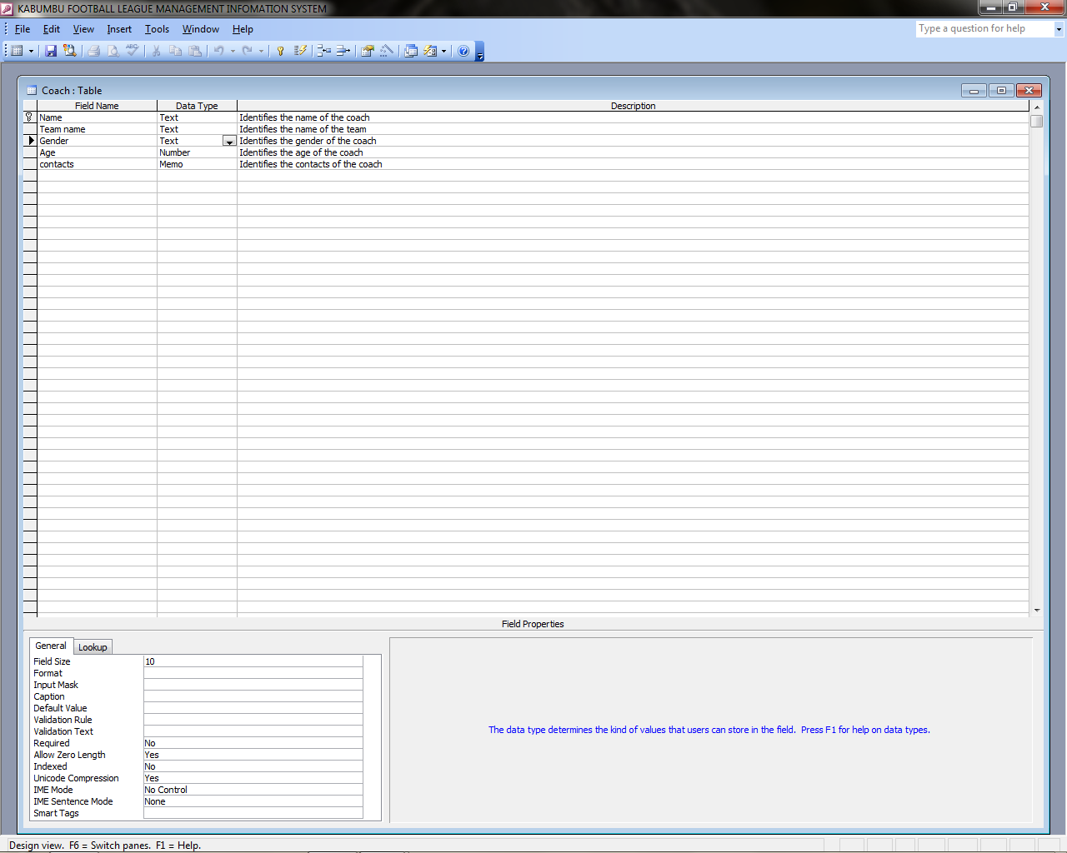

Table 3.1 Penalty card

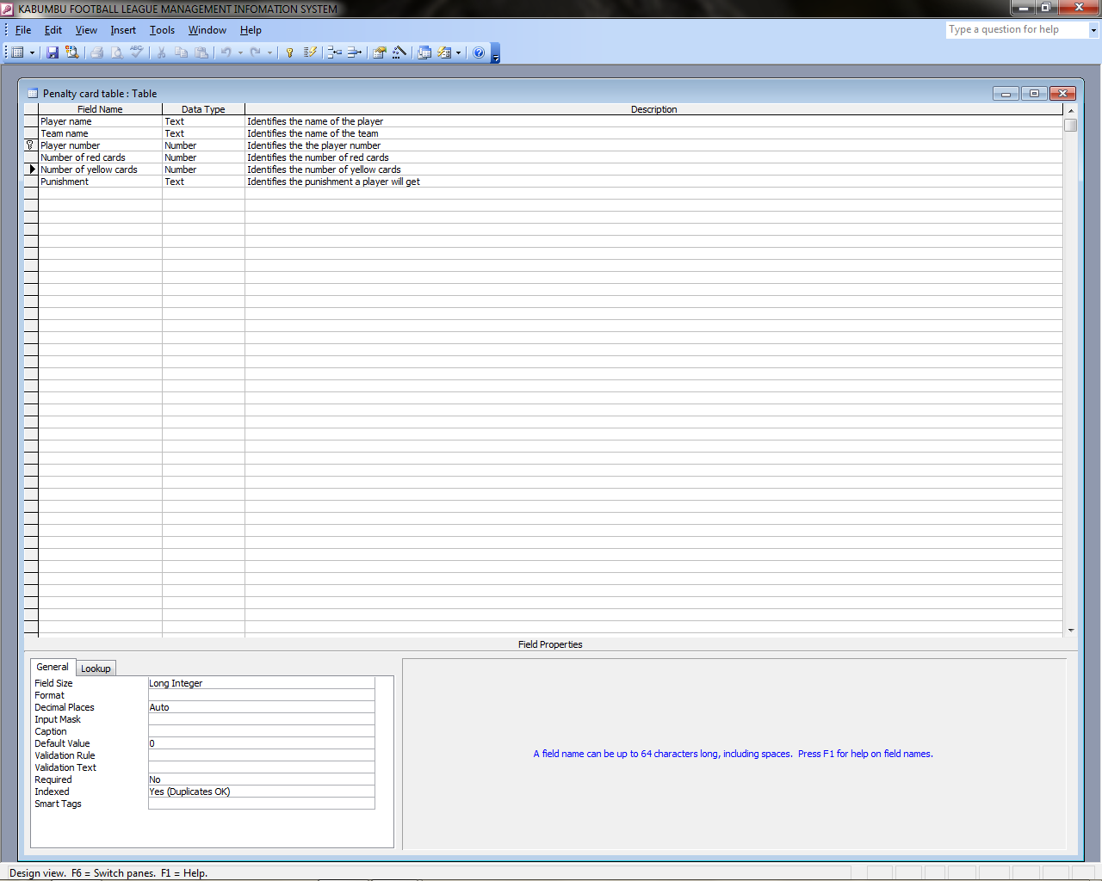

Fig 3.2Referee table

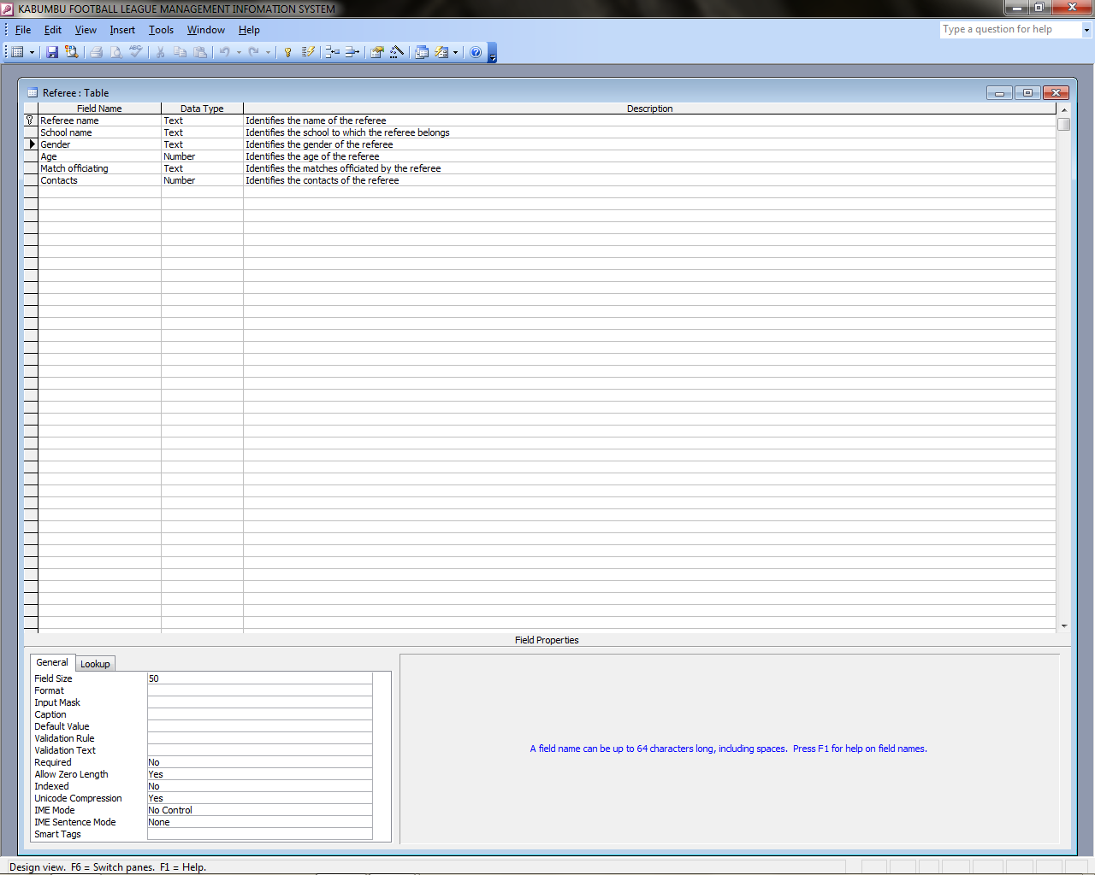

Table 3.3 Registration table

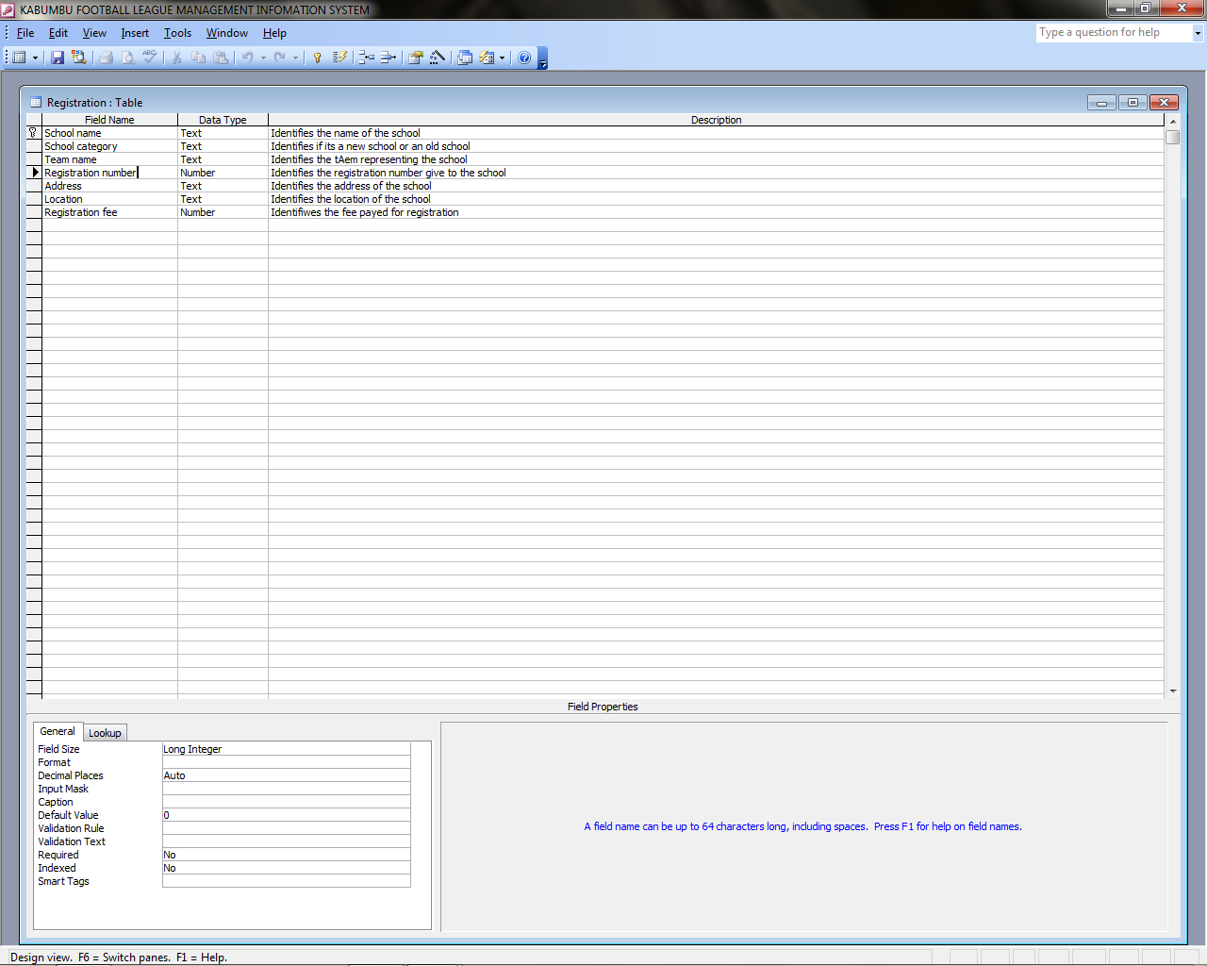

Table 3.4 League

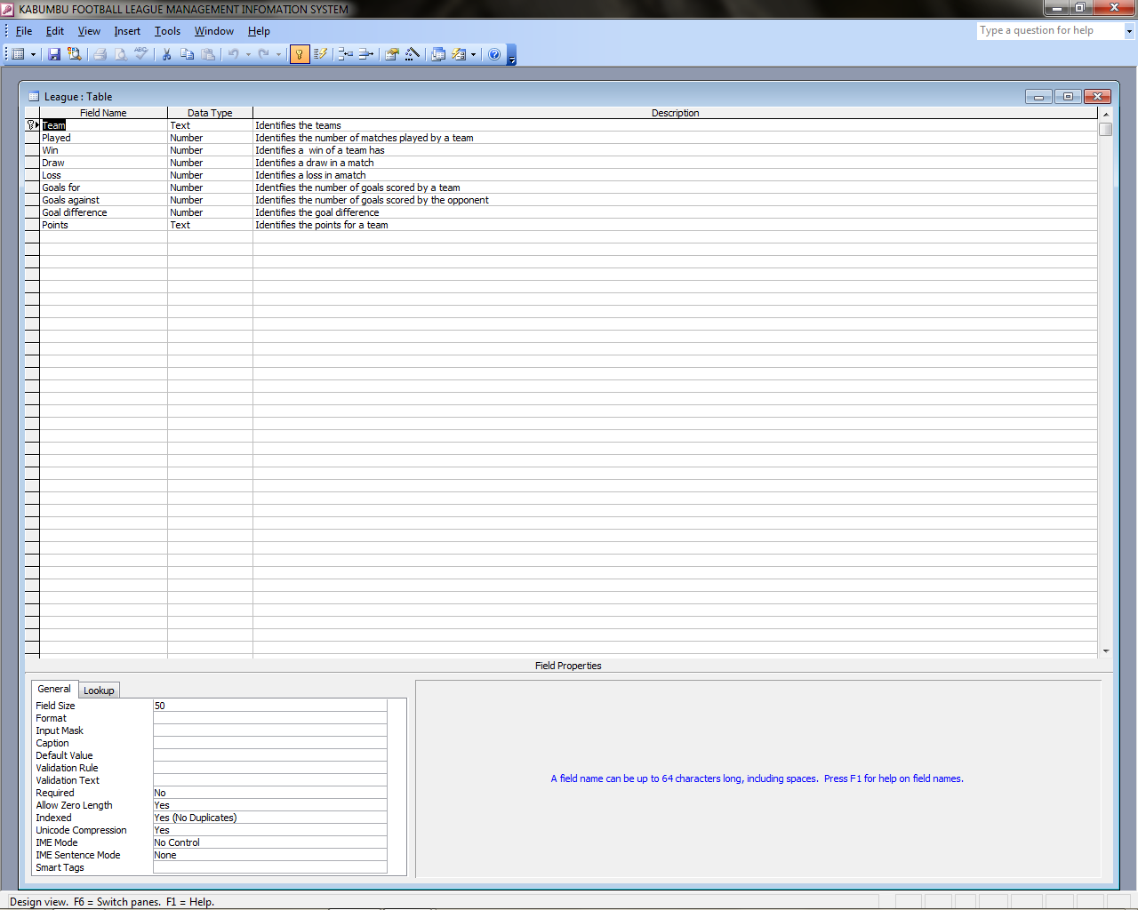

Table 3.5 Player table

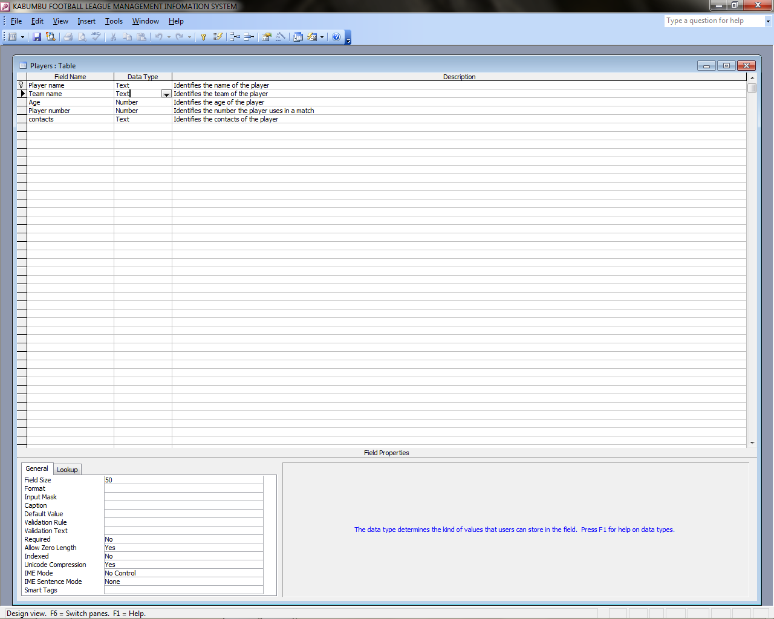

Table 3.6 Team table

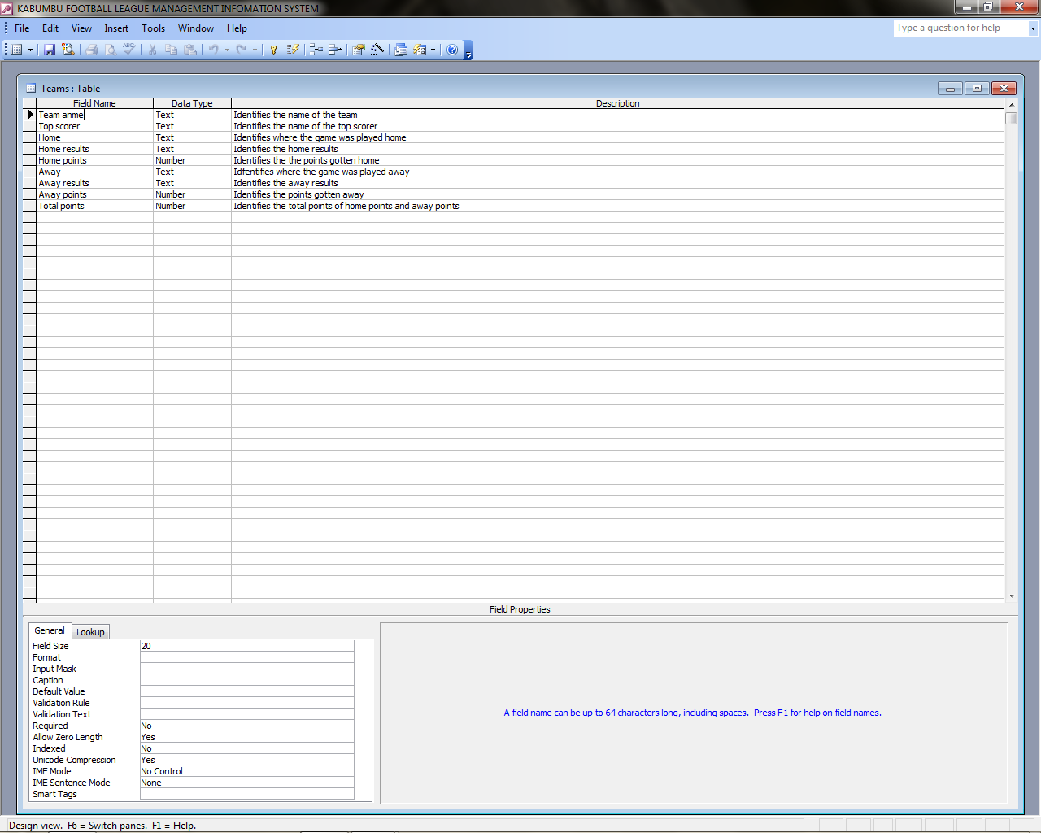

Table 3.7Reprimand table

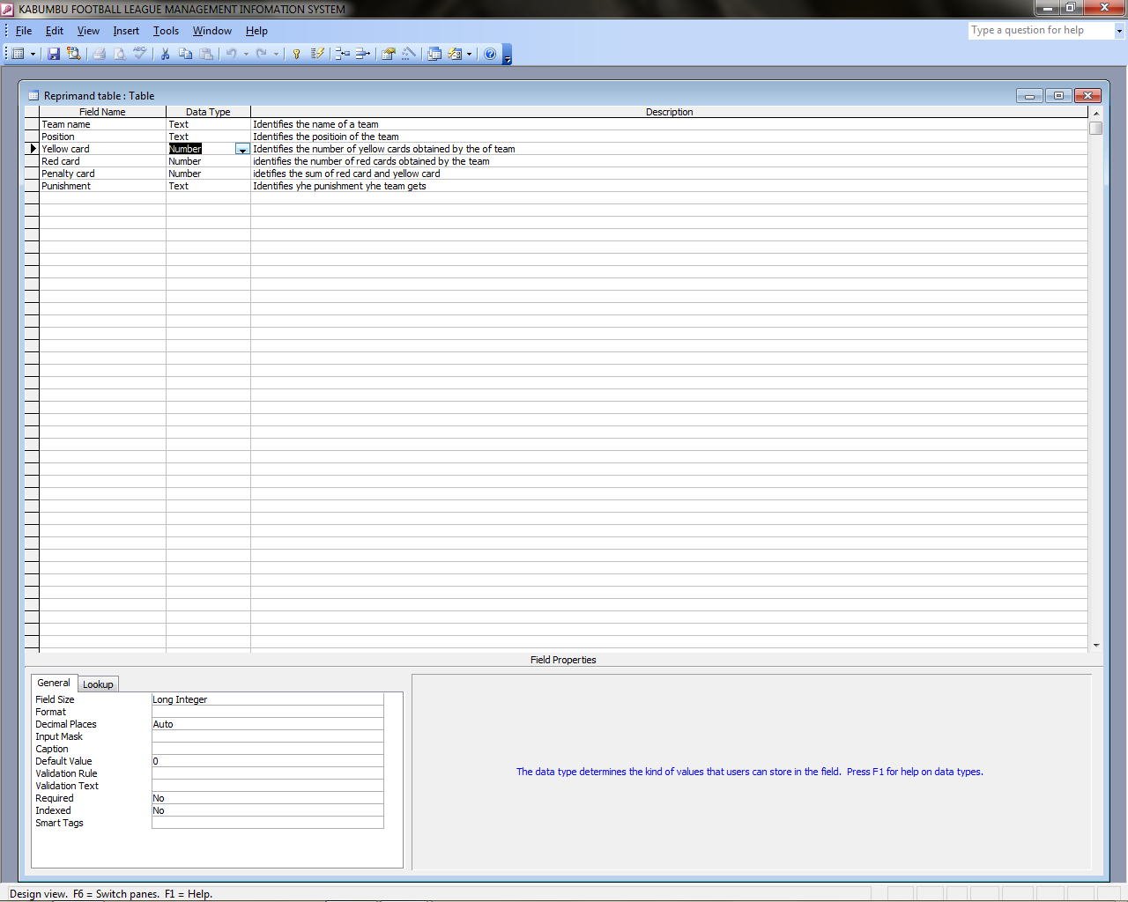

Table 3.8 Award

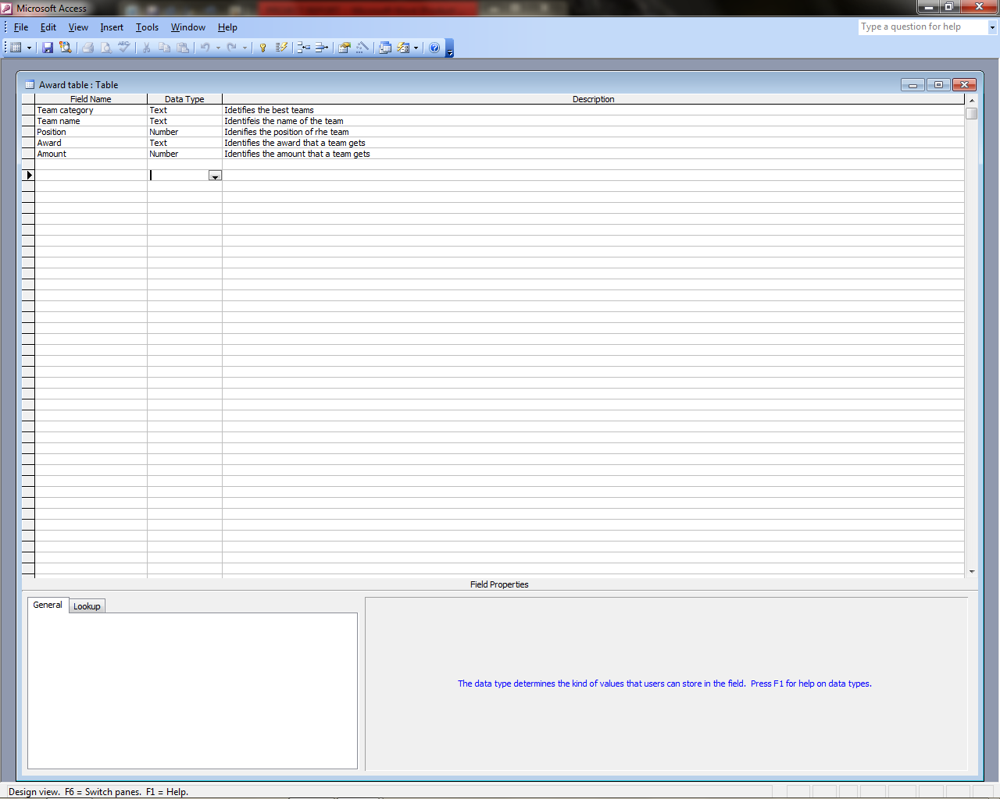

Table 3.9Unhoured games

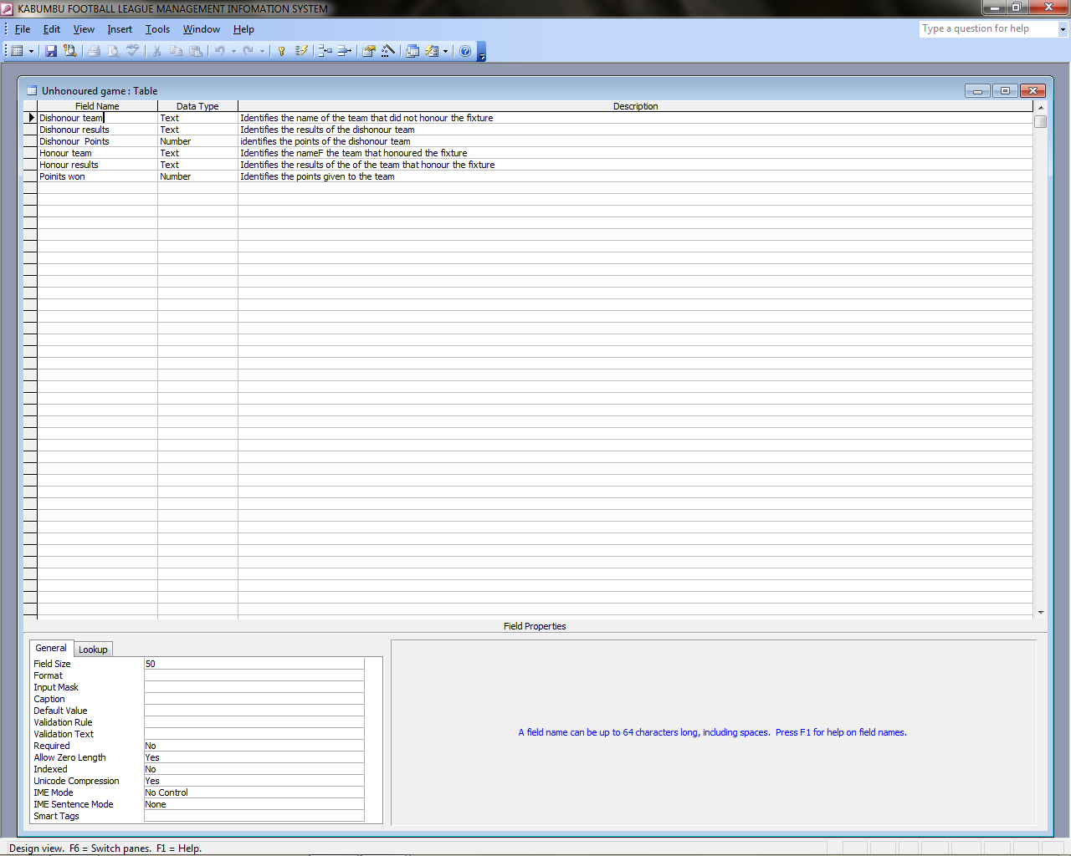

Table 3.10 Fixtures table

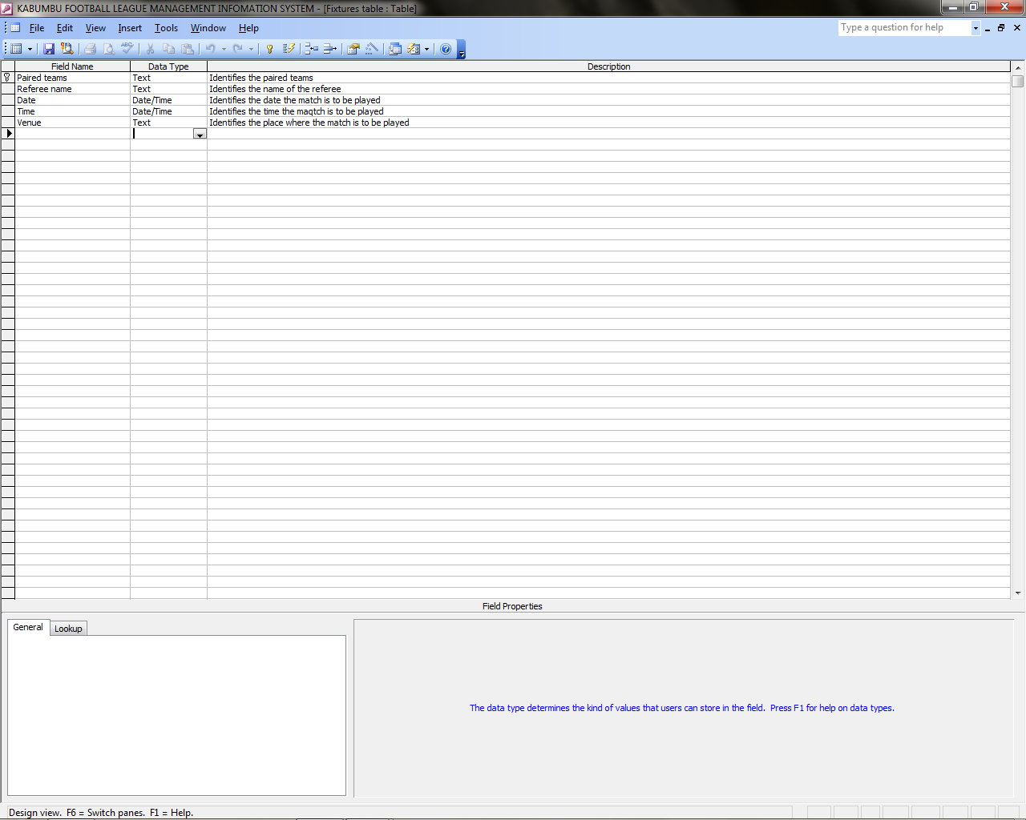

Fig 3.11 Fixtures form

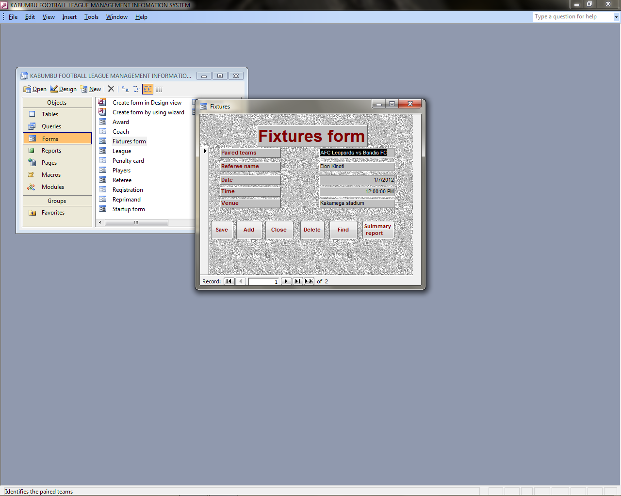

Fig 3.12 Unhoured games

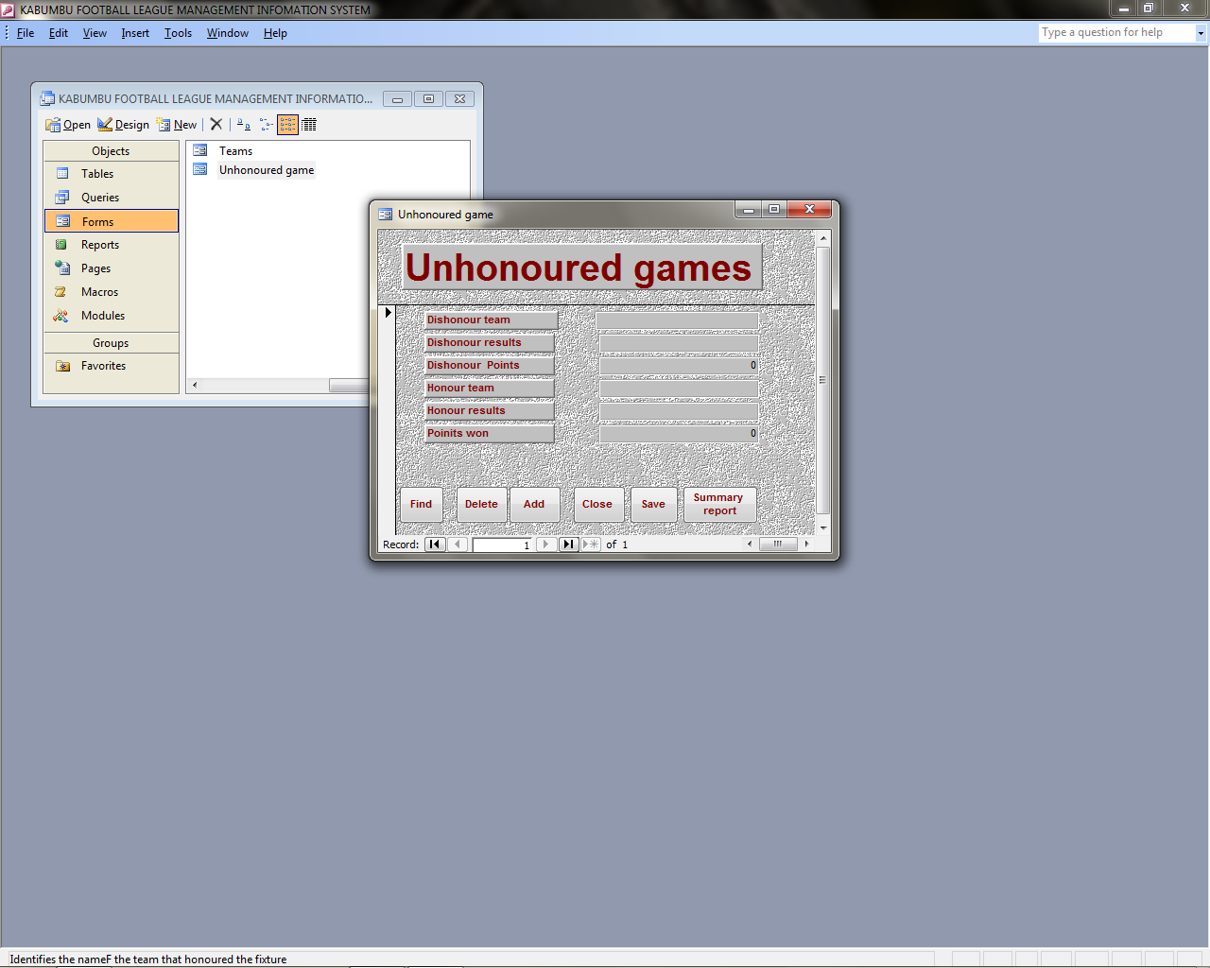

Fig 3.13League

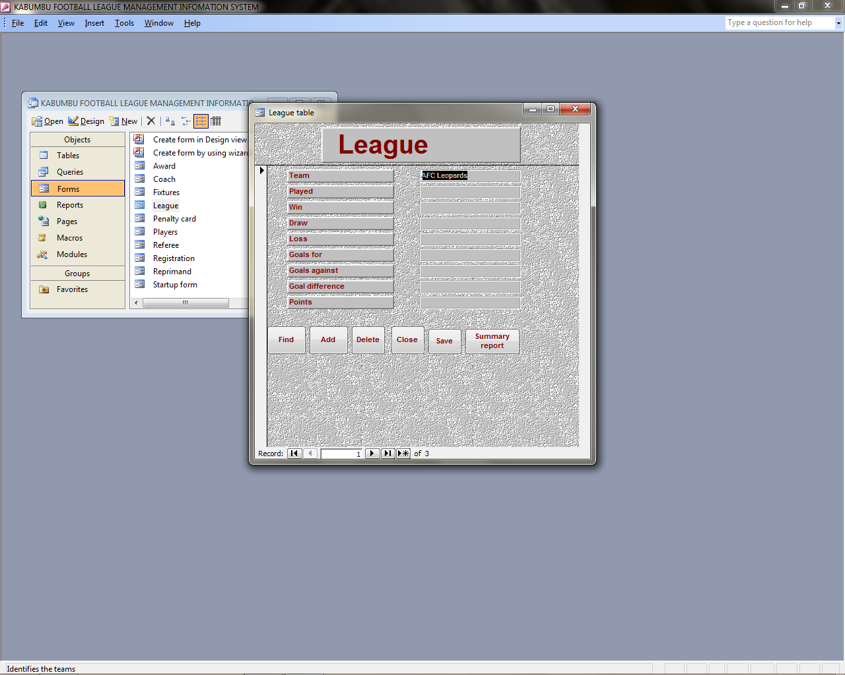

Fig 3.14 Teams form

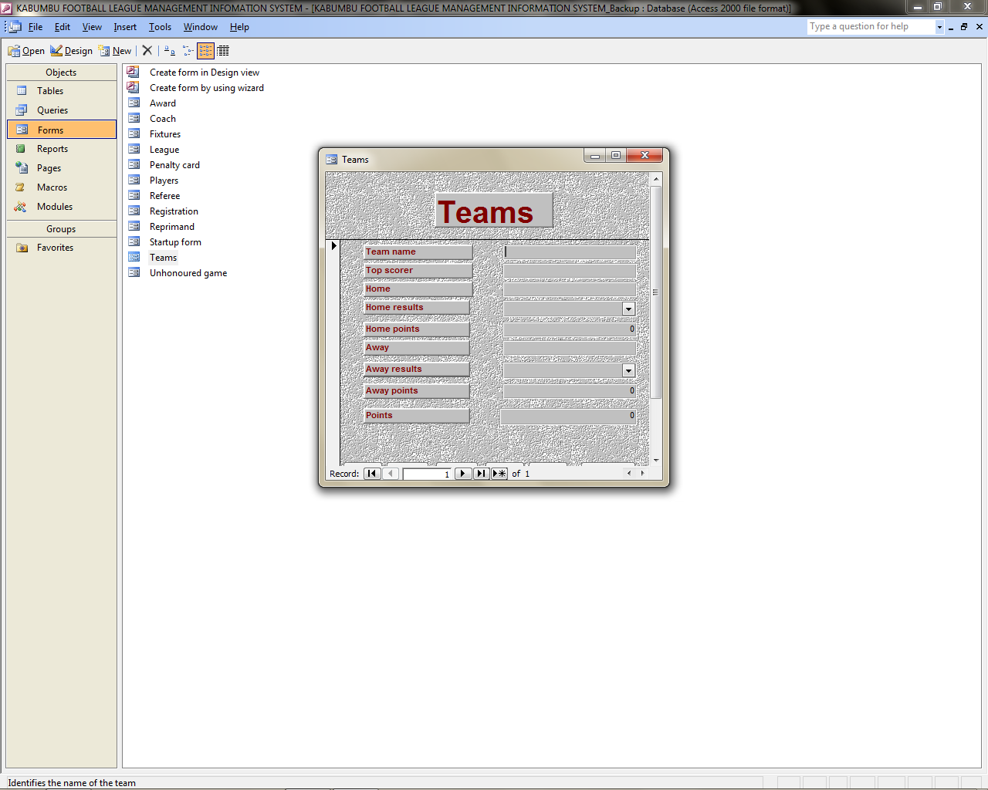

Fig 3.15 Penalty card form

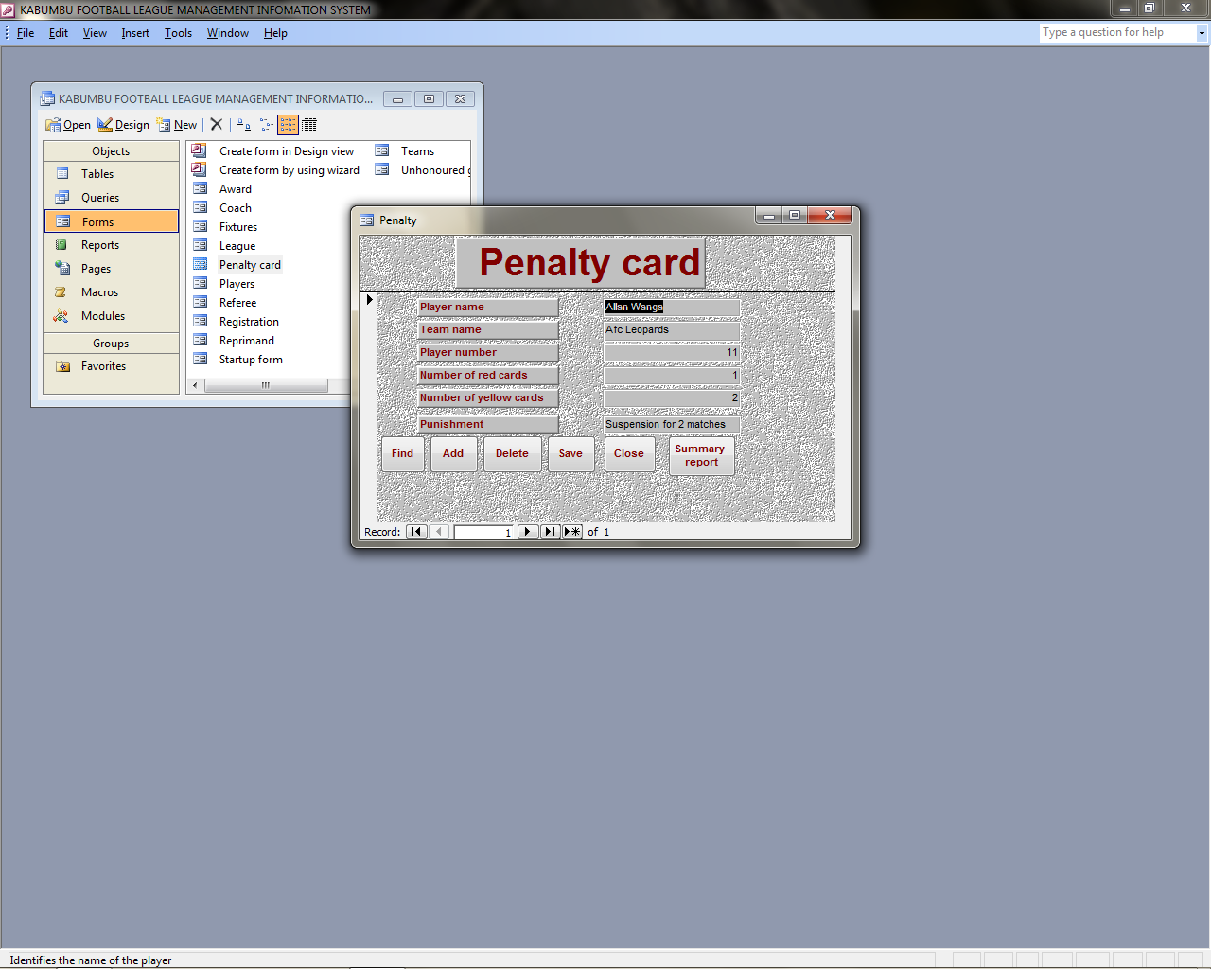

Fig 3.16 Reprimand form

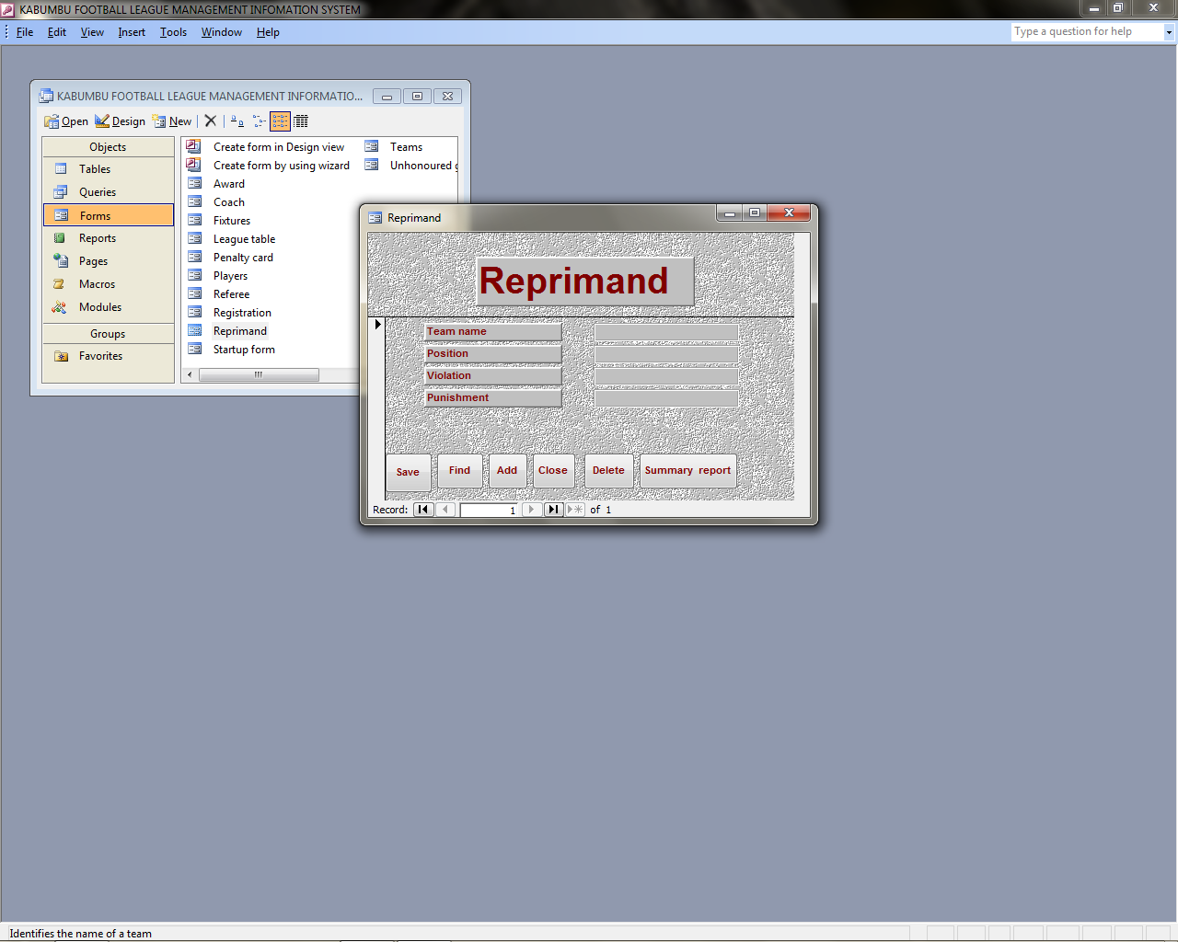

Fig 3.17 Referee form

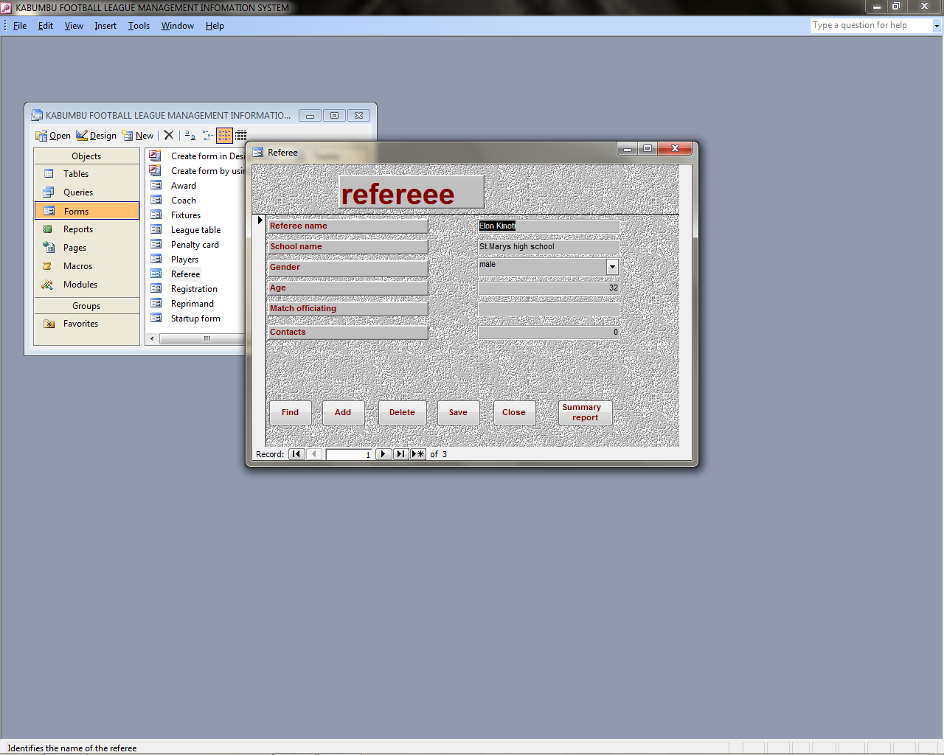

Fig 3.18 Coach form

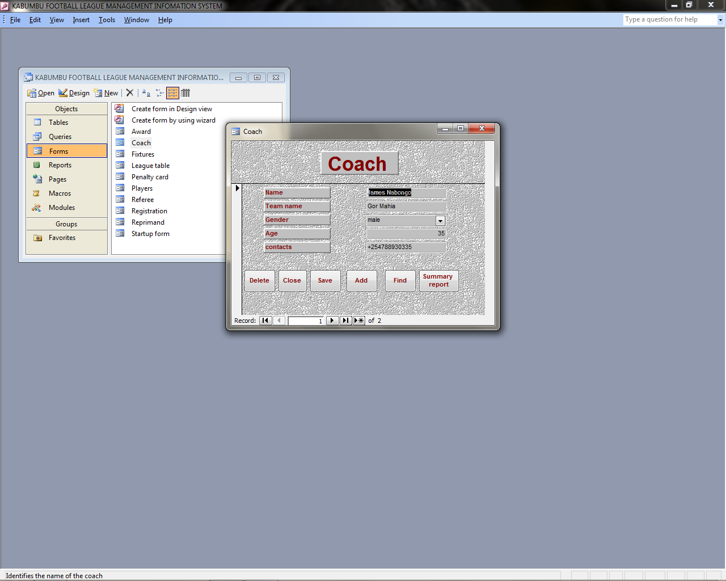

Figure 3.19 Registration form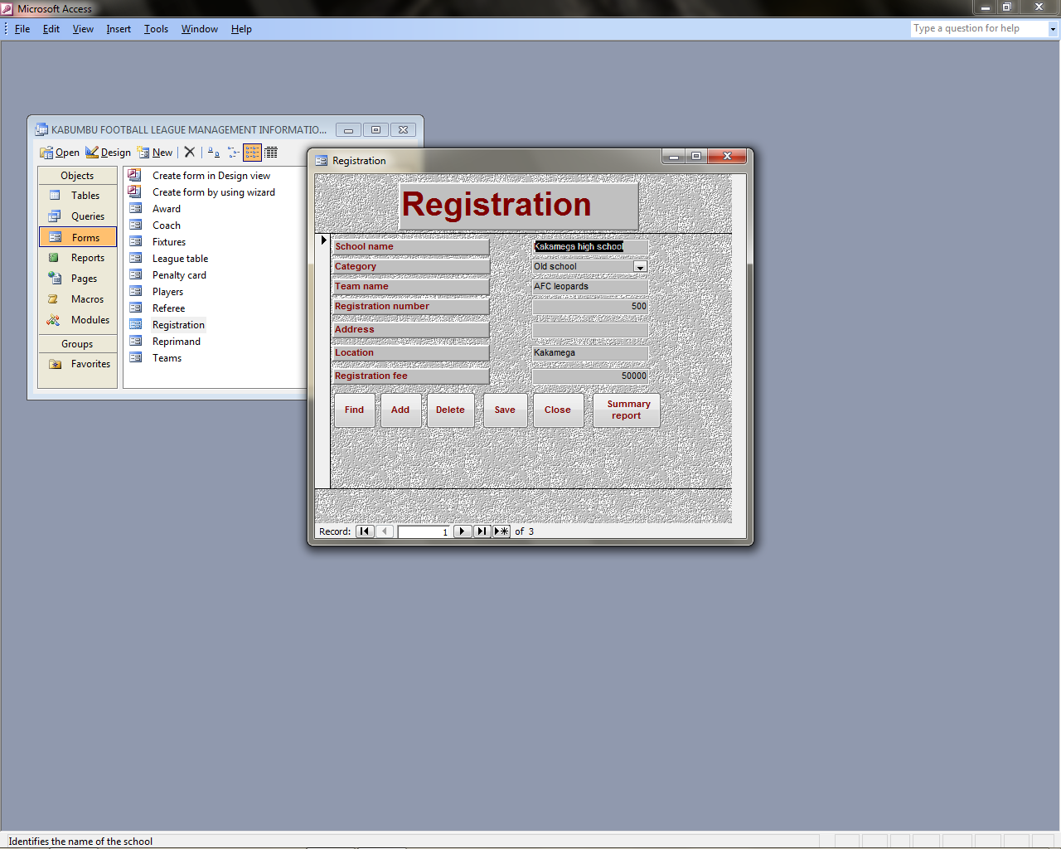

Fig 3.20 Players

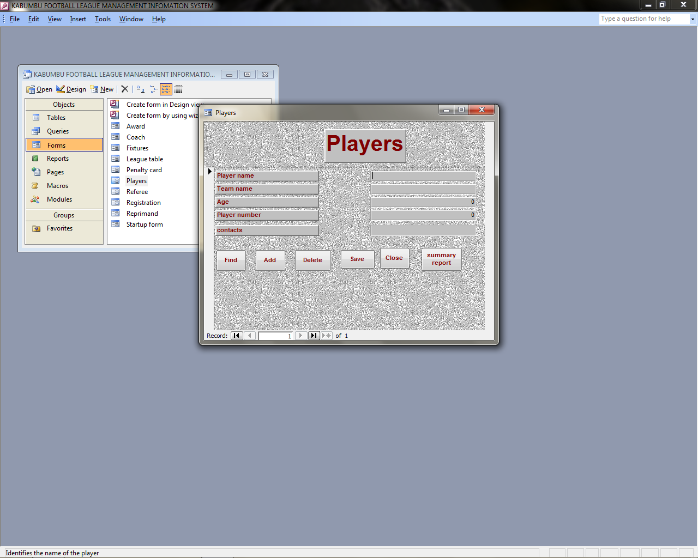Fig 3.21 Award form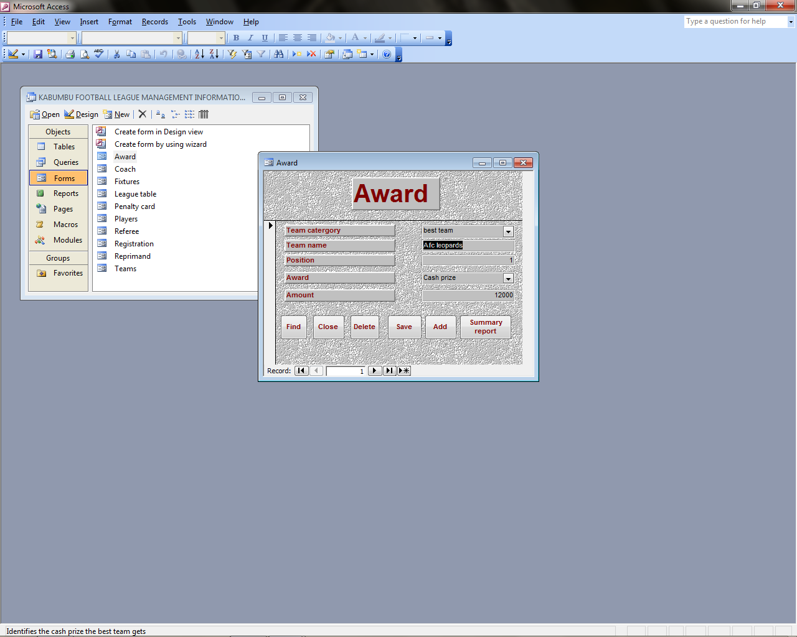

Fig 3.22 payment query

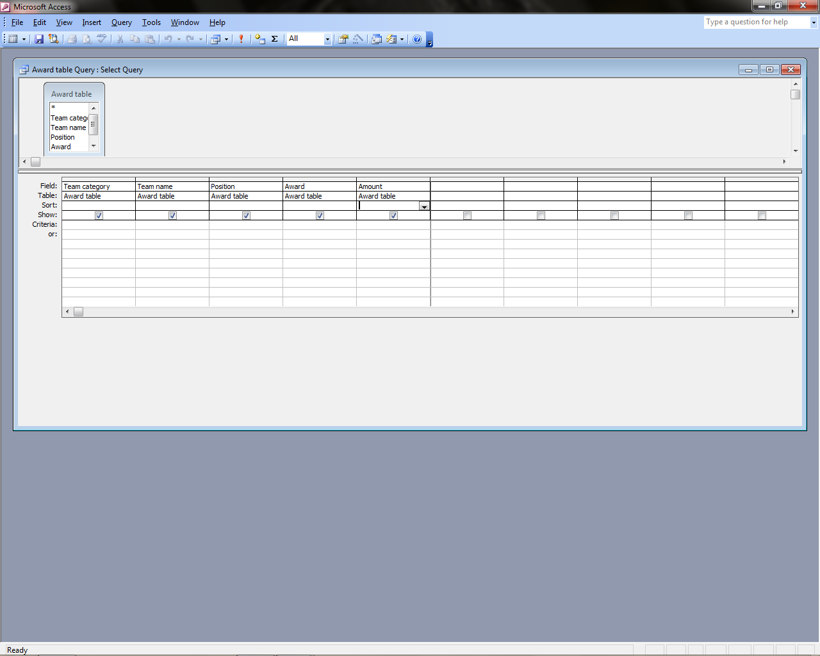

Fig 3.23 Award query

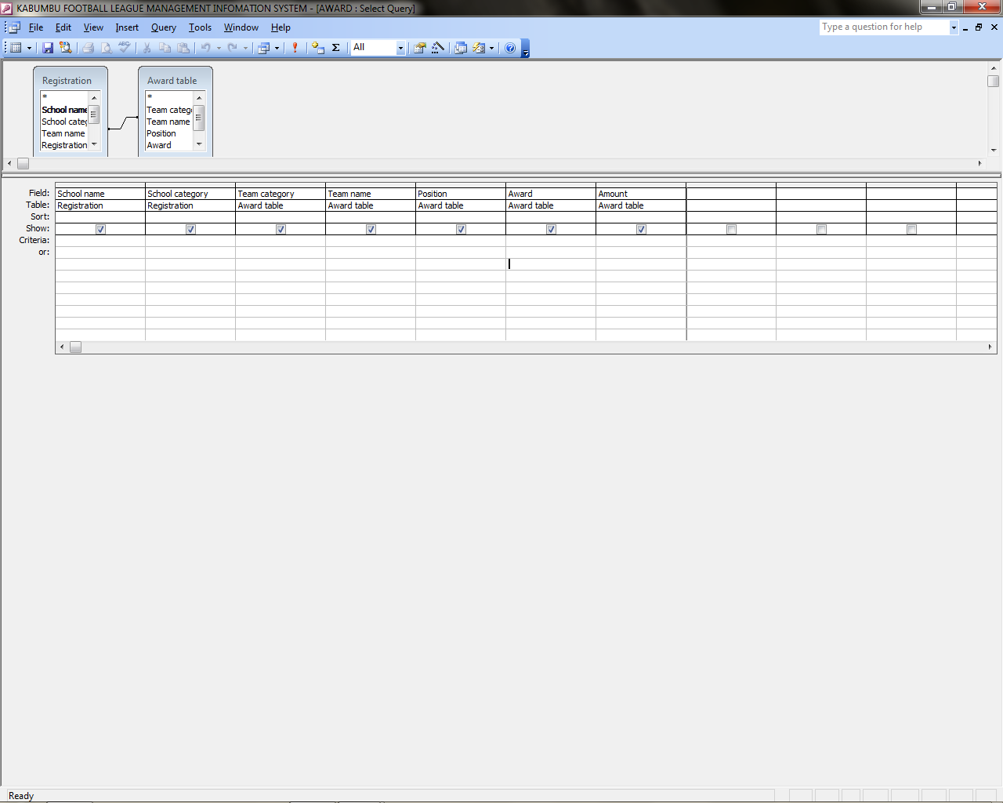

Fig 3.24 Relationship

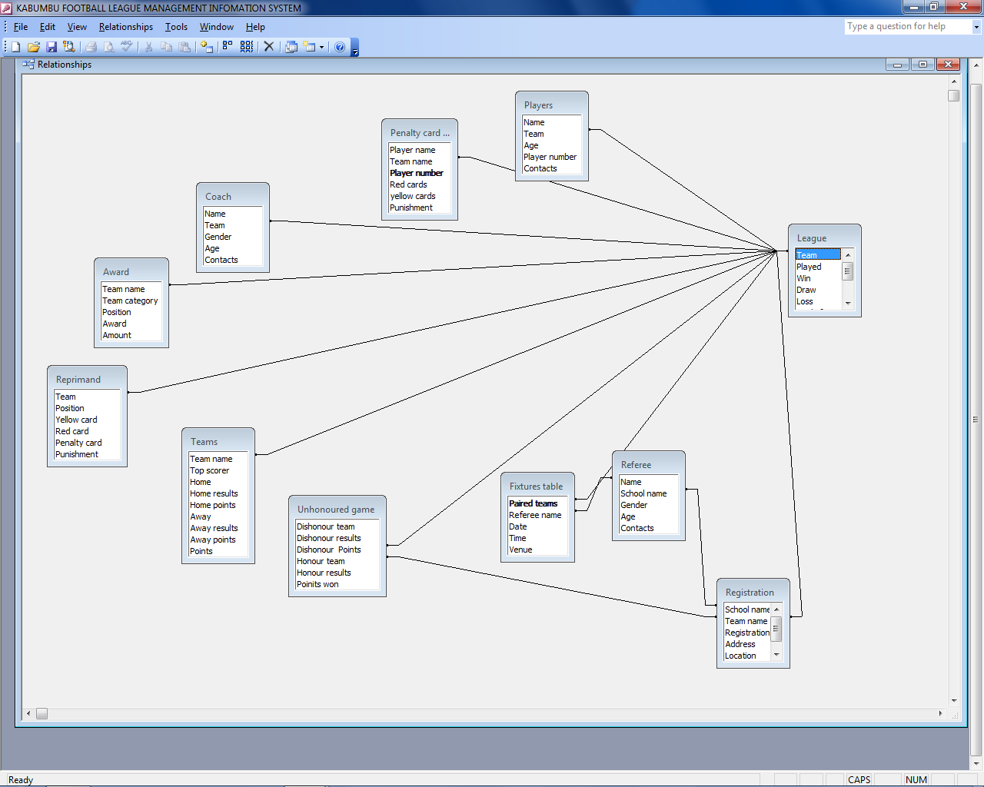

Fig 3.25 Registration Summaryreport

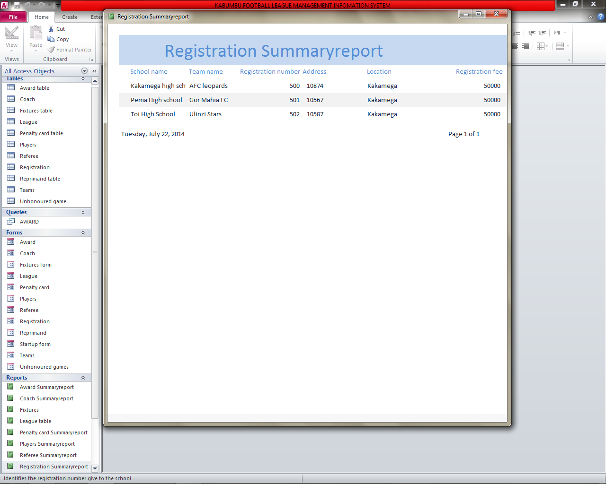

Fig 3.26Award Summary report

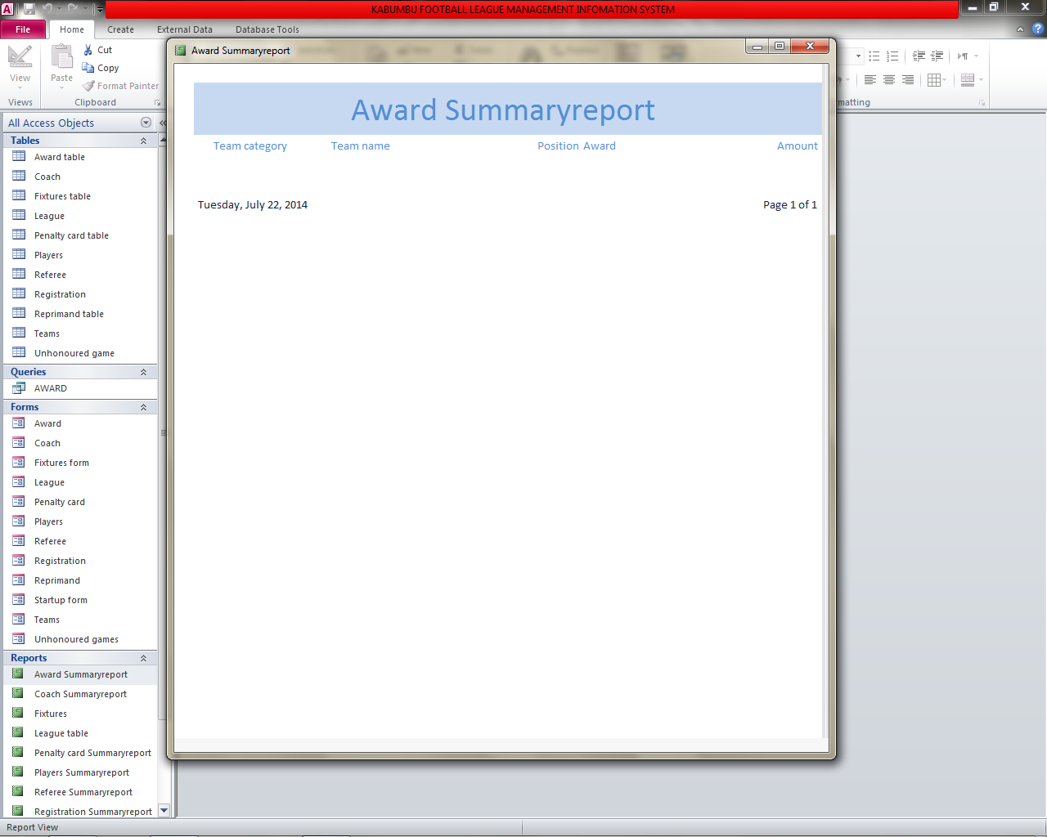

Fig 3.27 Fixtures

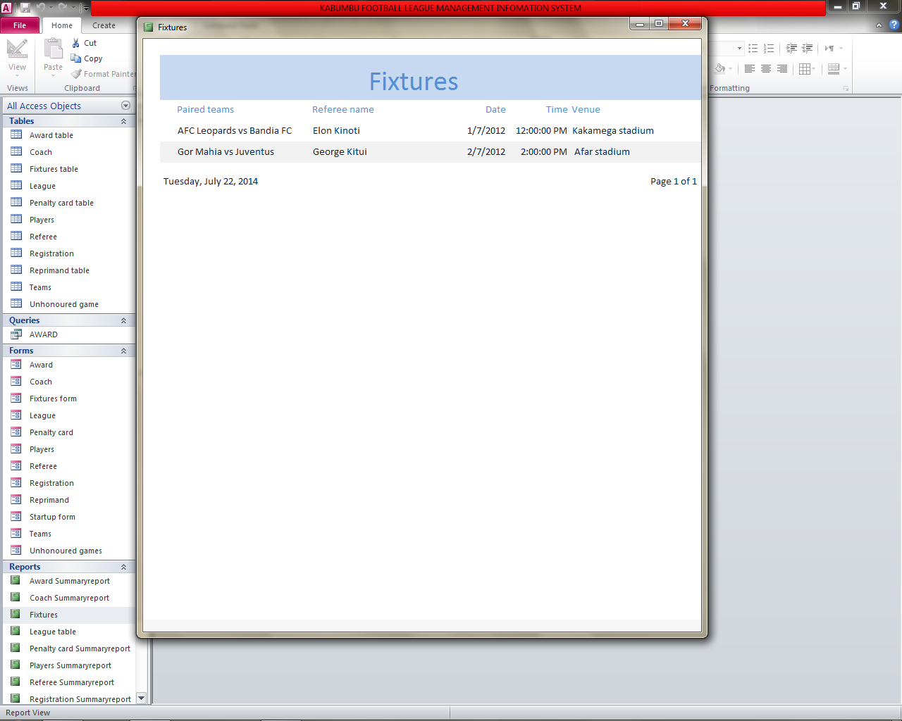

Fig 3.28 Coach Summaryreport

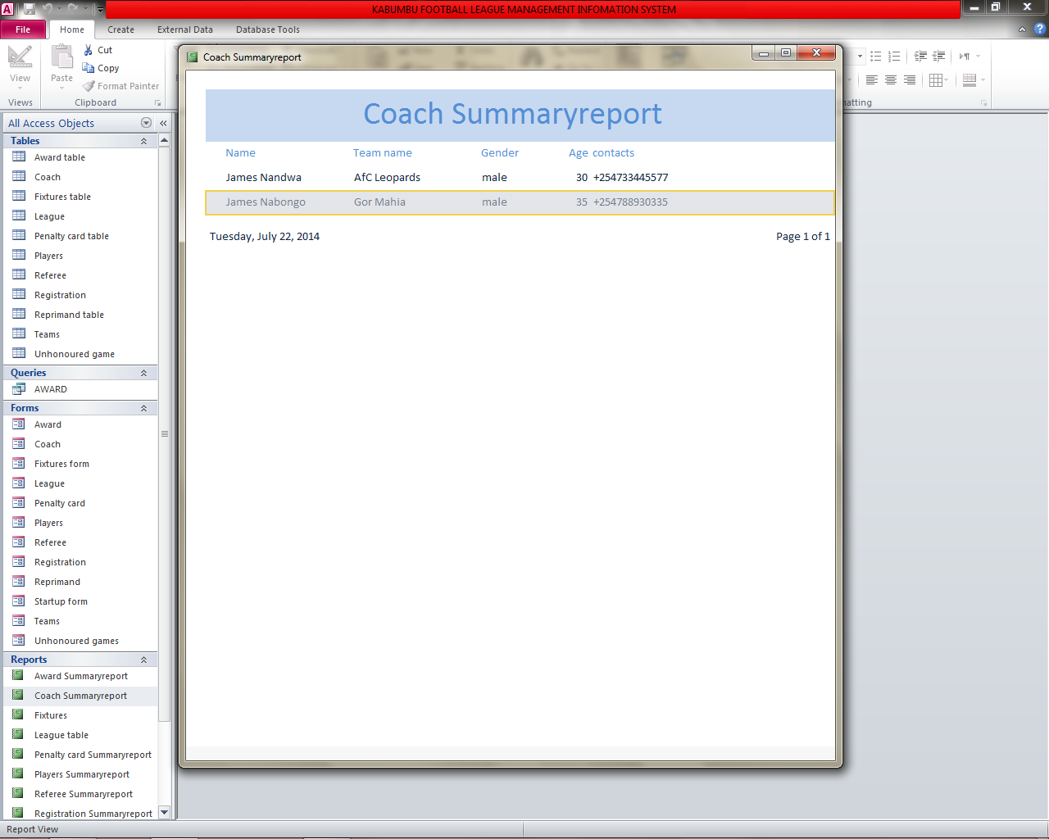

Fig 3.29 League table

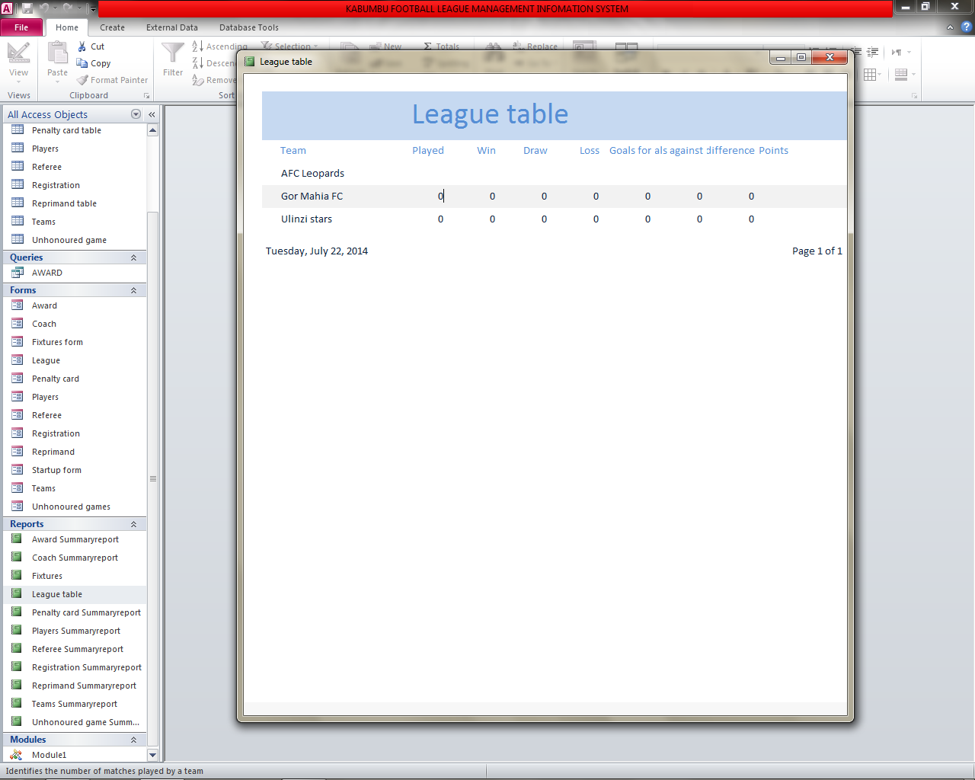

Fig 3.30 Penalty card Summaryreport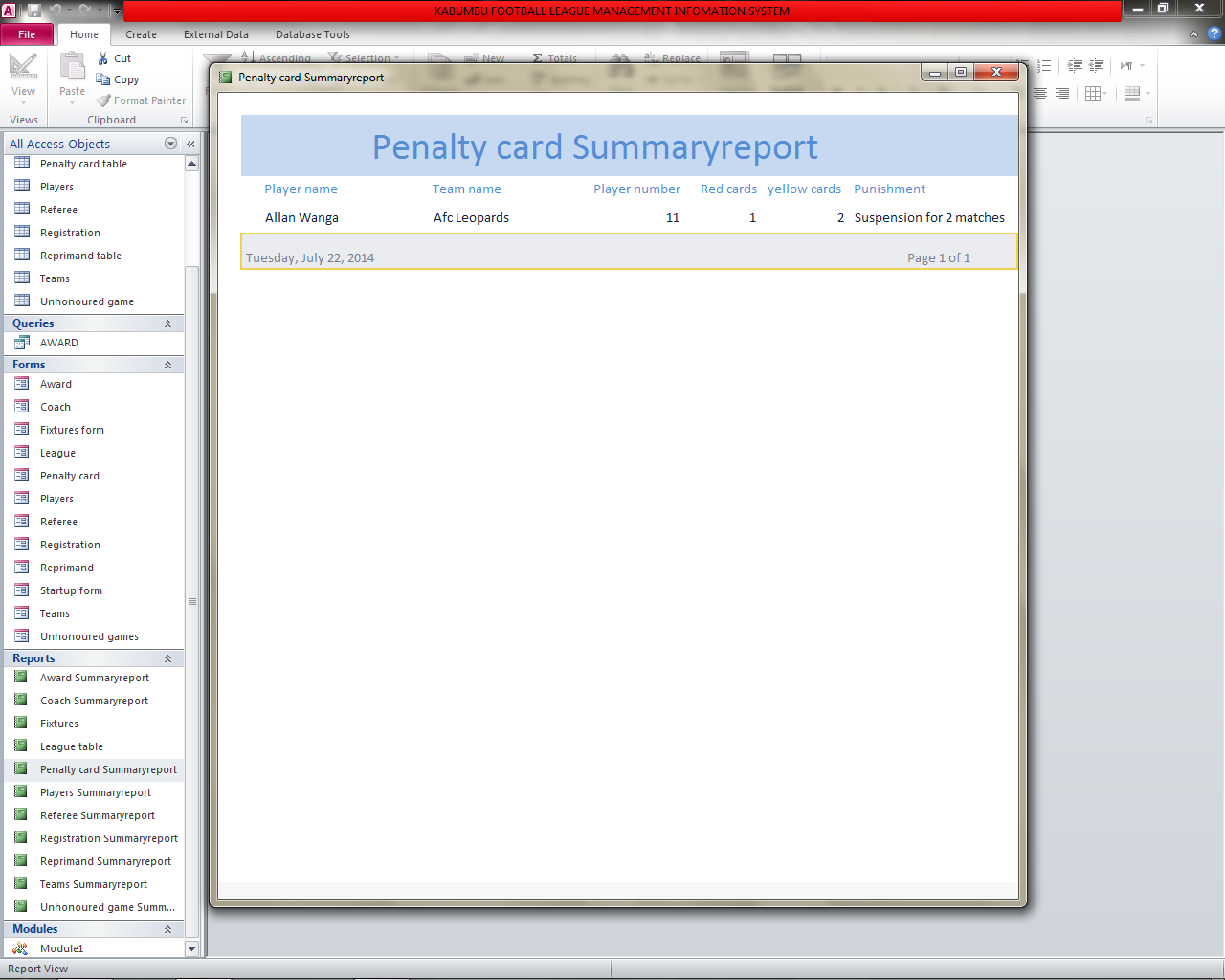

Fig 3.31 Players Summaryreport

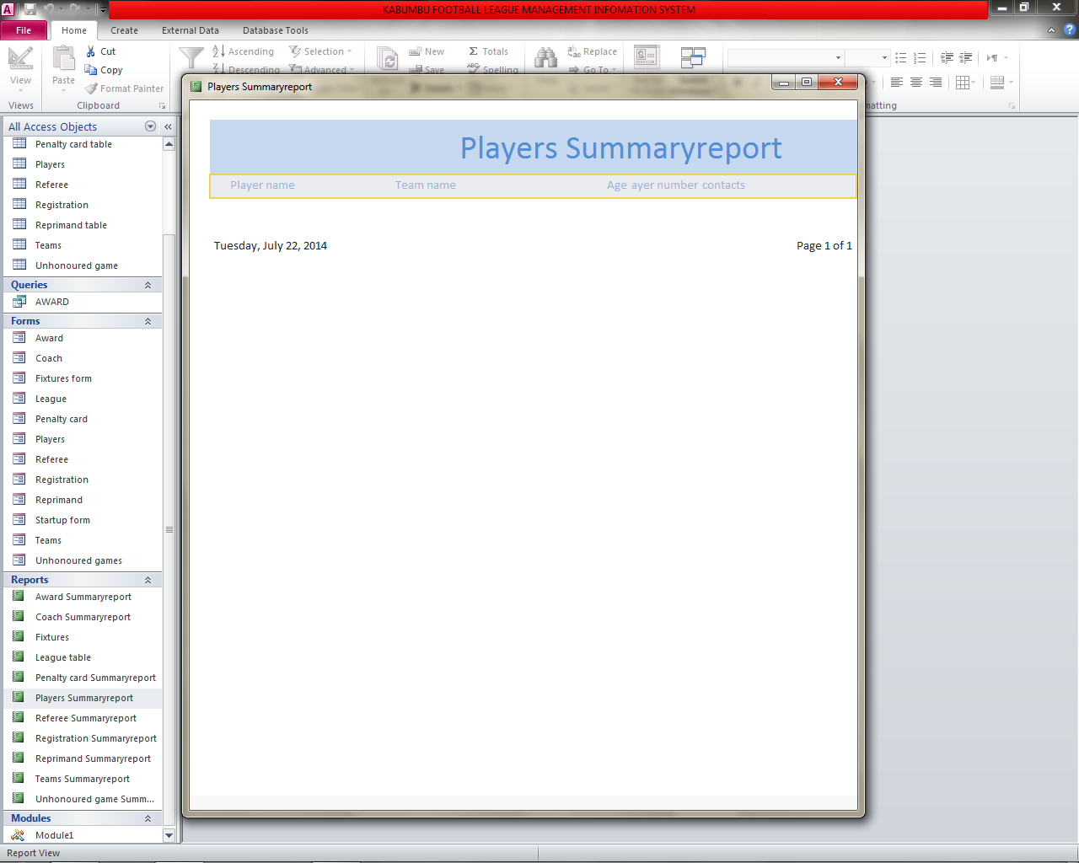

Fig 3.32 Referee Summaryreport

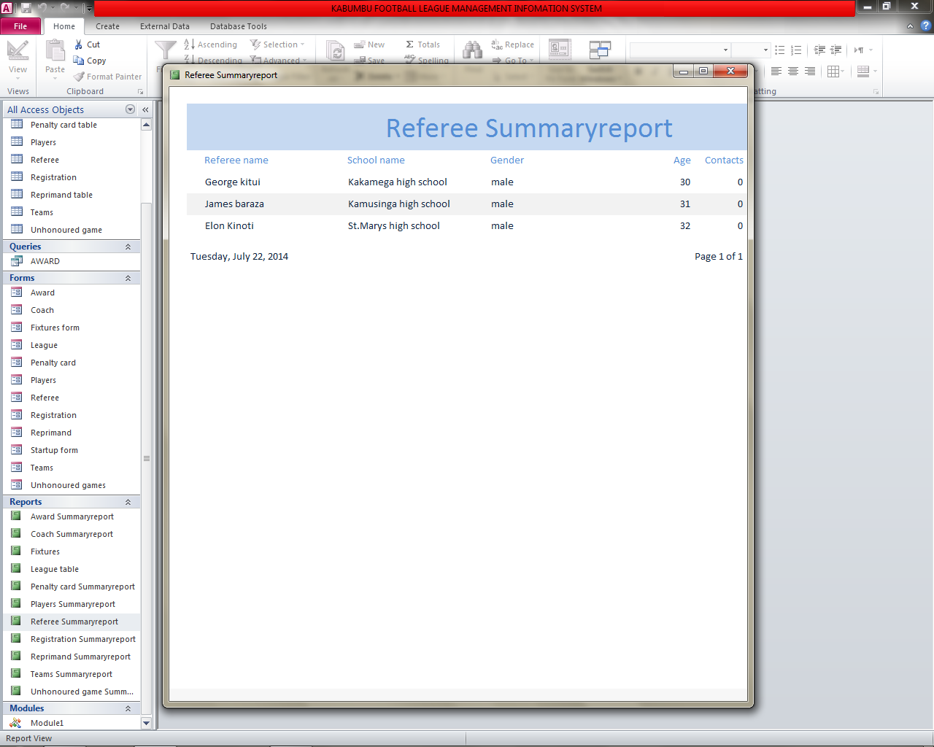

Fig 3.33 Reprimand Summaryreport

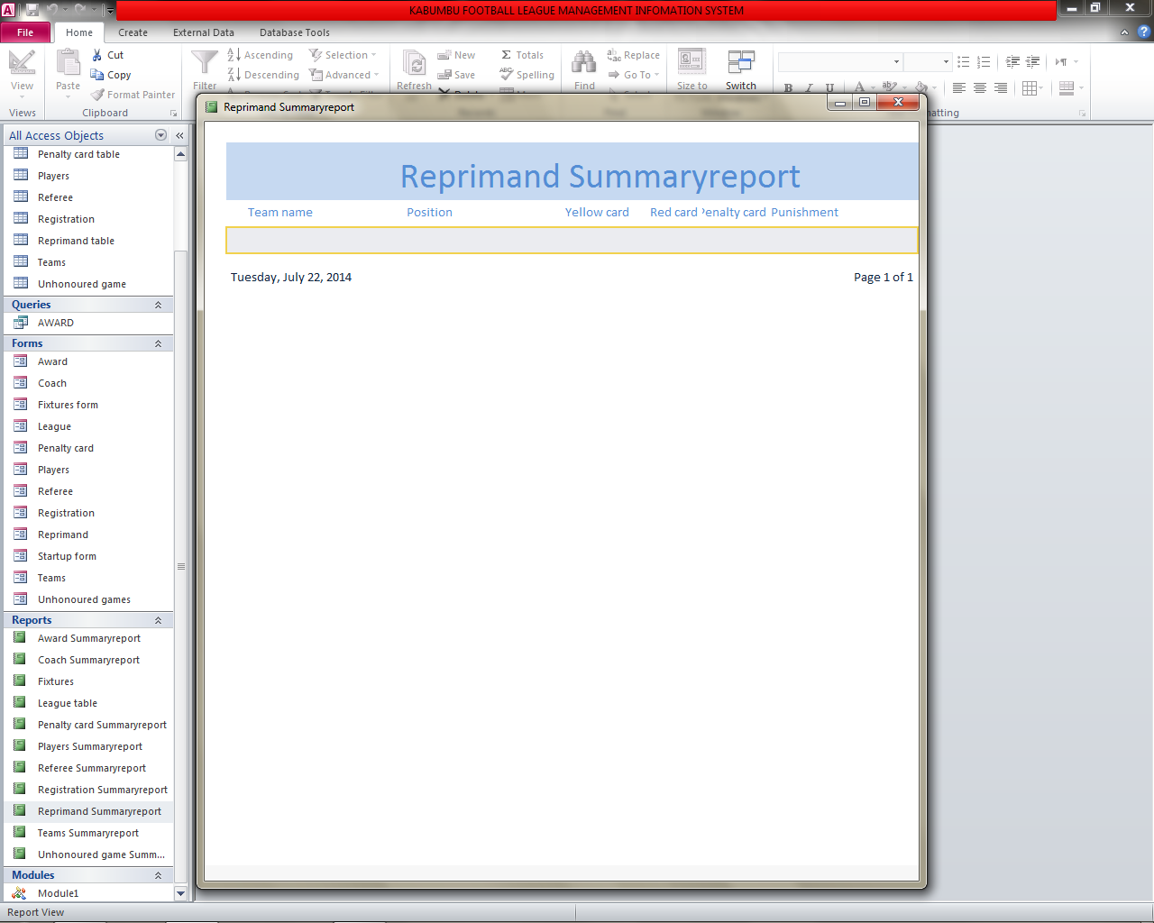

Fig 3.34 Teams Summaryreport

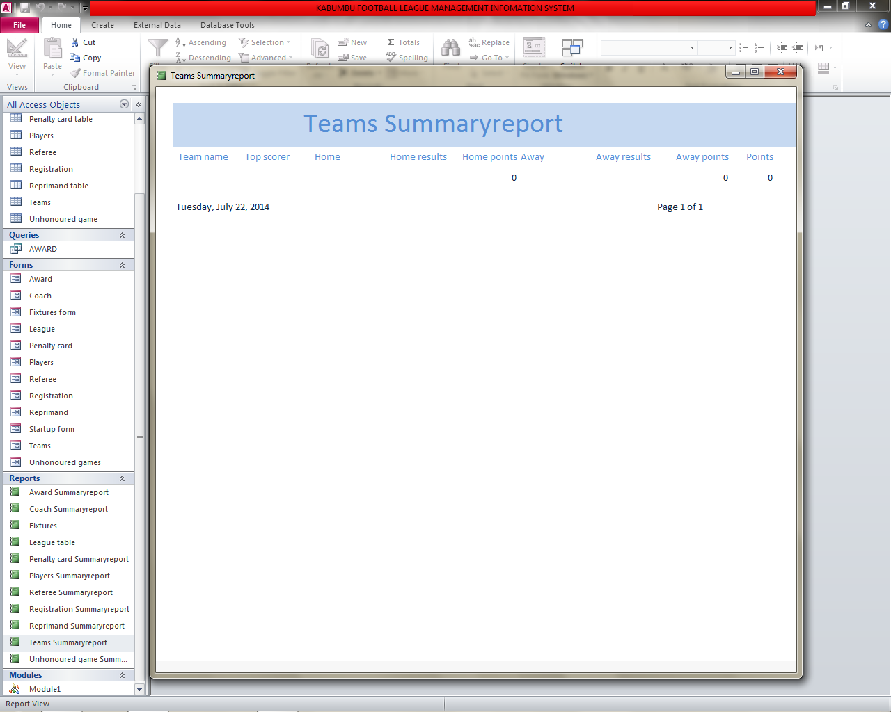

Fig 3.35 Unhonoured Summaryreport

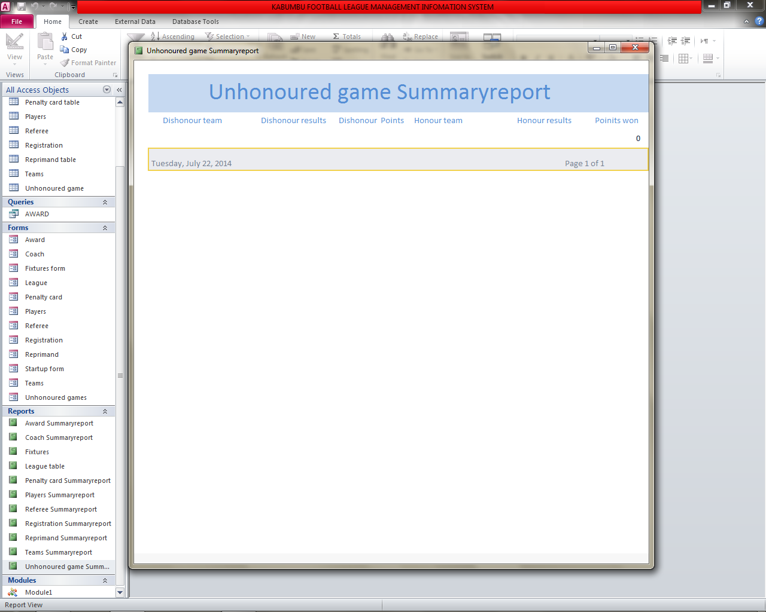

Fig 3.10 Codes

Private Sub cmdFind_Click()

'find record

S = MsgBox("Do you want to find record?", vbQuestion + vbYesNo, "KABUMBU FOOTBALL LEAGUE MANAGEMENT INFORMATION SYSTEM")

If S = vbYes Then

DoCmd.FindNext

Else

DoCmd.CancelEvent

End If

End Sub

Private Sub cmdDelete_Click()

'Deleting record

S = MsgBox("Do you want to delete record?", vbQuestion + vbYesNo, "KABUMBU FOOTBALL LEAGUE MANAGEMENT INFORMATION SYSTEM")

If S = vbYes Then

DoCmd.DeleteObject

Else

DoCmd.CancelEvent

End If

End Sub

Private Sub cmdAdd_Click()

'Add record

S = MsgBox("Do you want to add record?", vbQuestion + vbYesNo, "KABUMBU FOOTBALL LEAGUE INFORMATION SYSTEM")

If S = vbYes Then

DoCmd.GoToRecord , , acNewRec

Else

DoCmd.CancelEvent

End If

End Sub

Private Sub cmdSave_Click()

'Save record

S = MsgBox("Do you want to save record?", vbQuestion + vbYesNo, "KABUMBU FOOTBALL LEAGUE MANAGEMENT INFORMATION SYSTEM")

If S = vbYes Then

DoCmd.Save

Else

DoCmd.CancelEvent

End If

End Sub

Private Sub cmdClose_Click()

'Close record

S = MsgBox("Do you want to close form?", vbQuestion + vbYesNo, "KABUMBU FOOTBALL LEAGUE MANAGEMENT INFORMATION SYSTEM")

If S = vbYes Then

DoCmd.Close

Else

DoCmd.CancelEvent

End If

End Sub

Chapter 4:System Implementation

4.0 Introduction

This chapter describes how the system will be implemented and the strategies to be used to implement the system.It contains the following;

1. Implementation strategy
2. Implementation plan
3. User training whereby it will explain how the user training will be will done
4. User manual whereby it displays the following;

Hardware/software requirements of the system;

1. Hardware requirements

Some of the hard ware requires used were HP Computer and a flash disk which was used for storage of data

1. Software requirements

The software requirements;

* Installation guide
* Loading the system
* Navigation guide
* Glossery

Implementation Strategies

In this strategy, direct change over is used. The old system is stopped the new system is actived.

User Manual

4.1Step 1



Click on the start button and open on the various

4.2 Step 2



Click on all programs

4.3 Step 3



Click on Microsoft Office

4.4 Step 4

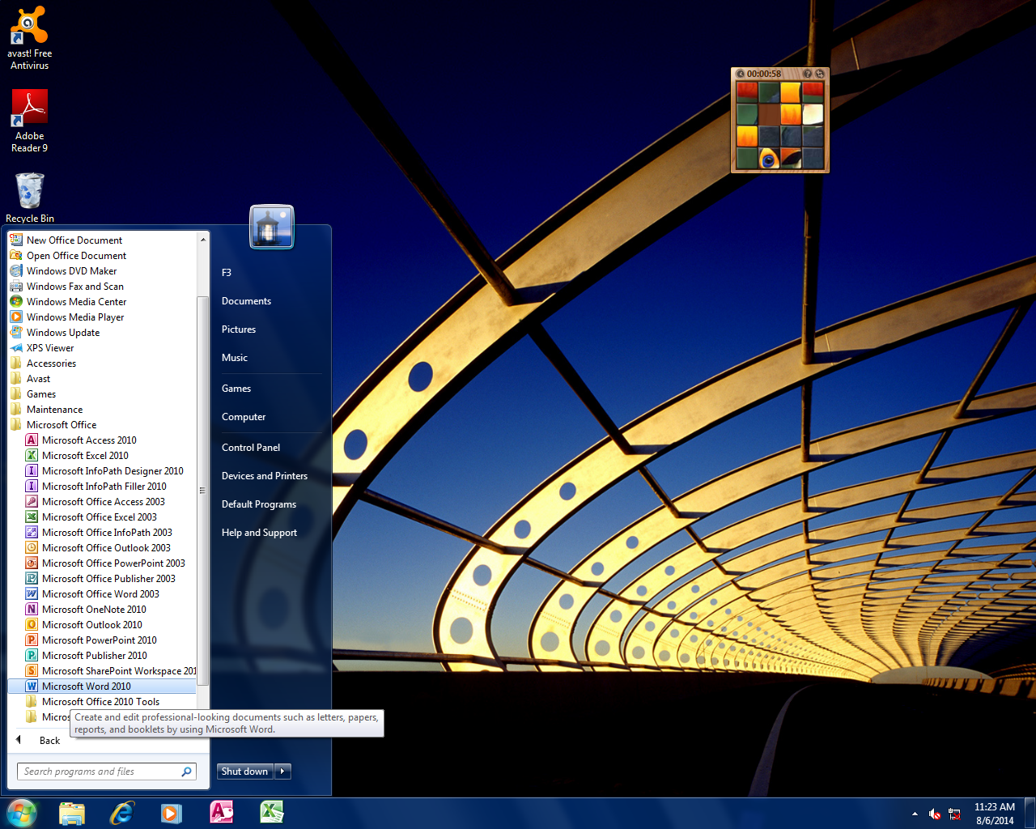

Click on Microsoft Word 2010

4.5Step 5. PROJECT REPORT

|  |  |  |  |  |
| --- | --- | --- | --- | --- |
|  | 2 week | 1 week | 2 month | 1 month |
| *Problem definition and recognition* |  |  |  |  |
| *Requirements specification* |  |  |  |  |
| *System construction* |  |  |  |  |
| *Compiling Reports* |  |  |  |  |

|  |
| --- |
| Player form  Player name  Team name  Age  Player number  Contacts  Add  Find  Save  Delete  Close |

This is a player form

This where data is entered

This is a command for saving a record

This is a command for closing a record

This is a command for deleting a record

This is a command for finding a record This is a command for adding a recordStep 2.6 Startup form

|  |  |
| --- | --- |
| |  | | --- | | KABUMBU FOOTBALL LEAGUE INFORMATION SYSTEM |   UNHOURED GAMES  PLAYERS  GAMES  RESULTS  AWARD    COACH    SCHOOL  PENALTY CARD  REFEREE  FIXTURES |